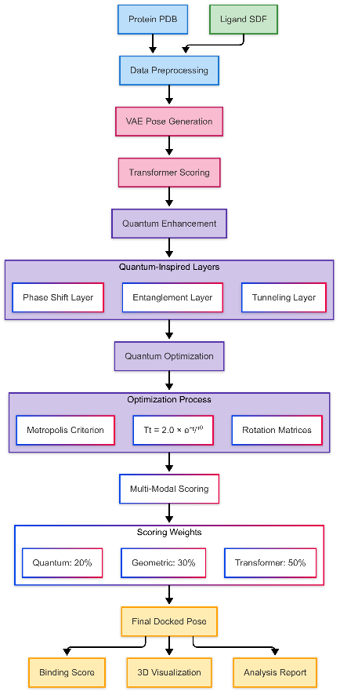

Main Algorithm
Algorithm 1: Main workflow combining VAE pose generation with quantum optimization
PROCEDURE GenerativeAIDocking()
// Initialize quantum-enhanced AI models
VAE ← VariationalAutoencoder(latent_dim=64)
TransformerScorer ← MultiHeadAttentionModel()
QuantumScorer ← QuantumInspiredNN()

// Load and preprocess data
protein_coords ← LoadPDBStructure(protein_file)
ligands ← SampleLigandsFromSDF(sdf_file, sample_size=N)

FOR each ligand IN ligands:
// Generative pose generation
generated_poses ← VAE.GeneratePoses(ligand_coords, n_poses=5)

best_score ← -∞
FOR each pose IN generated_poses:
// Quantum-enhanced optimization
optimized_pose, score ← QuantumEnhancedDocking(pose, protein_coords)

IF score > best_score:
best_pose ← optimized_pose
best_score ← score

// Multi-modal scoring
transformer_score ← TransformerScorer(protein_coords, best_pose)
quantum_score ← QuantumScorer(extract_features(protein_coords, best_pose))
final_score ← ensemble_scores(transformer_score, quantum_score)

StoreResults(ligand, best_pose, final_score)

GenerateComprehensiveAnalysis()
END PROCEDURE

Quantum Enhanced Docking
Algorithm 2: Quantum-inspired pose refinement with temperature scheduling

PROCEDURE QuantumEnhancedDocking(ligand_pose, protein_coords)
best_pose ← ligand_pose
best_score ← score_pose(protein_coords, ligand_pose)

FOR iteration = 1 TO max_iterations:
temperature ← quantum_temperature_schedule(iteration)

// Quantum-inspired transformations
rotation ← generate_quantum_rotation(temperature)
translation ← generate_quantum_translation(temperature)

new_pose ← apply_transformation(ligand_pose, rotation, translation)
new_score ← score_pose(protein_coords, new_pose)

// Quantum acceptance criterion
IF quantum_acceptance(new_score, best_score, temperature):
best_pose ← new_pose
best_score ← new_score

RETURN best_pose, best_score
END PROCEDURE

Transformer Based Scoring
Algorithm 3: Multi-head attention mechanism for protein-ligand interaction scoring

FUNCTION TransformerScorer(protein_coords, ligand_coords)
protein_features ← MLP_Encoder(protein_coords) // [batch, atoms, features]
ligand_features ← MLP_Encoder(ligand_coords) // [batch, atoms, features]

// Multi-head attention for interactions
combined_features ← concatenate(protein_features, ligand_features)
attended_features ← MultiHeadAttention(combined_features)

// Final scoring
score ← MLP_Scorer(mean_pool(attended_features))
RETURN score
END FUNCTION

Quantum-Inspired Neural Layers

CLASS QuantumEntanglementLayer:
FORWARD(x):
RETURN sin(πx) + cos(πx/2) // Non-linear entanglement simulation

CLASS QuantumTunnelingLayer:
FORWARD(x):
WITH probability p:
RETURN x * 3 // Amplified feature tunneling
ELSE:
RETURN x

3.1 Variational Autoencoder for Pose Generation
Evidence Lower Bound (ELBO):
$$LVAE​\left(θ,ϕ;x\right)=Eqϕ​\left(z ∣ x\right)​\left[logpθ​\left(x ∣ z\right)\right]-β⋅DKL​\left(qϕ​\left(z ∣ x\right)∥p\left(z\right)\right)$$
where:
- $x∈R256x∈R256$: flattened ligand coordinates
- $z∈R64z∈R64$: latent pose representation
- $qϕ\left(z ∣ x\right)qϕ​\left(z ∣ x\right)$: encoder network
- $pθ\left(x ∣ z\right)pθ​\left(x ∣ z\right):$ decoder network
- $ββ: KL$ divergence weight

Reparameterization Trick:
$$z=μϕ​\left(x\right)+σϕ​\left(x\right)⊙ϵ,ϵ∼N\left(0,I\right)$$

3.2 Transformer-Based Scoring Function
Multi-Head Attention:
$$Attention\left(Q,K,V\right)=softmax\left(\frac{QK}{\sqrt{d_{k}}}​\right)V$$
$$MultiHead\left(Q,K,V\right)=Concat\left(head1,…,headh\right)W^{O}$$
where:
- $Q,K,V$: query, key, value matrices from protein-ligand features
- $d_{k}​:$ dimension of key vectors
- $h=4$: number of attention heads

Final Scoring Function:
$$stransformer​=σ\left(W_{2}​⋅ReLU\left(W_{1}​⋅hˉ+b_{1}​\right)+b_{2}​\right)$$
where:
- $hˉ=\frac{1}{N}​\sum_{i=1}^{N}{h_{i}}$​: mean-pooled attended features
- σ: sigmoid activation

3.3 Quantum-Inspired Optimization
Quantum Temperature Schedule:
$$T\left(t\right)=T_{0}⋅\exp\left(-\frac{t}{τ}\right), T_{0}=2.0, τ=10$$

Quantum Rotation Matrix:
$$R\left(α,β,γ\right)=R_{z}\left(γ\right)R_{y}\left(β\right)R_{x}\left(α\right)$$
where:
$$Ⅎb\{R\}_x(α) = 〖\{bmatrix\} 1 \& 0 \& 0 \backslash \backslash 0 \& cos⁡α\& - sin⁡α\backslash \backslash 0 \& sin⁡α\& cos⁡α〗\{bmatrix\}$$
$R_{x}\left(α\right)=\left[\begin{matrix}1 & 0 & 0 \\ 0 & cos α & -sin β \\ 0 & sin α & cos α\end{matrix}\right]$, $R_{y}$($β)$ = $\left[\begin{matrix}cos β & 0 & sin β \\ 0 & 1 & 0 \\ - sin β & 0 & cos β\end{matrix}\right]$

Rx​(α)=​100​0cosαsinα​0−sinαcosα​​,Ry​(β)=​cosβ0−sinβ​010​sinβ0cosβ​​

Quantum Tunneling Transformation:
$$x^{'}=x+Δt⋅I_{ξ<p_{tunnel}}​​$$
where:
- $Δt∼N\left(0,3T\left(t\right)I\right)$ : tunneling displacement
- $p_{\text{tunnel}}=0.1$ : tunneling probability
- $ξ∼U\left(0,1\right)$ : uniform random variable
Metropolis-Hastings Acceptance:
$$A\left(x→x^{'}\right)=\min\left(1,\exp\left(\frac{s\left(x^{'}\right)-s\left(x\right)}{T\left(t\right)}+η\right)\right)$$
where:
- $η∼N\left(0,0.1\right)$ quantum fluctuation term
- s(⋅): scoring function

3.4 Geometric Scoring Function
Distance-Based Scoring:
$$s_{\text{geometric}}=\frac{1}{N_{l}}\left[2\sum_{i=1}^{N_{l}}{I_{2≤d_{i}<4}}+\sum_{i=1}^{N_{l}}{I_{d_{i}<4}}-5\sum_{i=1}^{N_{l}}{I_{d_{i}<1.5}}\right]⋅\max\left(0,1-\frac{|c_{p}-c_{l}|_{2}}{20}\right)$$

where:

- $d_{i}=\min_{j}{|p_{j}}-l_{i}|_{2}$minimum protein-ligand distance
- $c_{p}$,$c_{l}$​ protein and ligand centroids
- $N_{l}$​: number of ligand atoms

3.5 Quantum-Inspired Neural Layers
Quantum Entanglement Layer:
$$f_{\text{entangle}}\left(x\right)=\sin\left(πx\right)+\cos\left(\frac{π}{2}x\right)$$
Quantum Phase Shift Layer:
$f_{\text{phase}}\left(x\right)=2⋅\arctan\left(x\right)$
3.6 Ensemble Scoring
Final Composite Score:
$$s_{\text{final}}=λ_{1}s_{\text{transformer}}+λ_{2}s_{\text{quantum}}+λ_{3}s_{\text{geometric}}$$
where:
- $λ_{1}=0.5,λ_{2}=0.3,λ_{3}=0.2$: weighting coefficients
- $s_{\text{quantum}}=s_{\text{transformer}}⋅\left(1+0.1ϵ\right), ϵ∼N\left(0,1\right)$

2025-09-28 21:47:04,950 - INFO - 🔍 Scanning research dataset...
2025-09-28 21:47:04,954 - INFO - 📊 Dataset Summary:
2025-09-28 21:47:04,954 - INFO - • RCSB PDB files: 20
2025-09-28 21:47:04,955 - INFO - • ChEMBL SDF files: 1
2025-09-28 21:47:04,956 - INFO - • Total size: 6128.31 MB
2025-09-28 21:47:04,958 - INFO - 📁 Loading protein: 1a0j
🧠 GENERATIVE AI MOLECULAR DOCKING SYSTEM
============================================================
This system combines:
• Variational Autoencoders (VAE) for pose generation
• Transformers for interaction scoring
• GANs for diverse pose sampling
• Quantum-inspired algorithms for optimization
============================================================
🚀 GENERATIVE AI + QUANTUM-ENHANCED DOCKING ANALYSIS
================================================================================

🔬 ANALYZING: 1a0j + chembl_33
============================================================
2025-09-28 21:47:05,132 - INFO - ✅ Protein loaded successfully:
2025-09-28 21:47:05,134 - INFO - • Atoms: 6640
2025-09-28 21:47:05,137 - INFO - • Center: [28.29639232 40.78856069 69.98221536]
2025-09-28 21:47:05,139 - INFO - • Radius: 57.83 Å
2025-09-28 21:47:05,142 - INFO - • Residues: 220
2025-09-28 21:47:05,145 - INFO - 📁 Loading ligands from: chembl_33.sdf
[21:47:14] Both bonds on one end of an atropisomer are on the same side - atoms is : 6
[21:47:19] Explicit valence for atom # 0 P, 7, is greater than permitted
[21:47:19] ERROR: Could not sanitize molecule ending on line 2985308
[21:47:19] ERROR: Explicit valence for atom # 0 P, 7, is greater than permitted
[21:47:24] Explicit valence for atom # 1 P, 7, is greater than permitted
[21:47:24] ERROR: Could not sanitize molecule ending on line 3747292
[21:47:24] ERROR: Explicit valence for atom # 1 P, 7, is greater than permitted
[21:47:25] Explicit valence for atom # 1 P, 7, is greater than permitted
[21:47:25] ERROR: Could not sanitize molecule ending on line 3912696
[21:47:25] ERROR: Explicit valence for atom # 1 P, 7, is greater than permitted
[21:47:27] Warning: ambiguous stereochemistry - opposing bonds have opposite wedging - at atom 10 ignored.
[21:47:27] Warning: ambiguous stereochemistry - opposing bonds have opposite wedging - at atom 10 ignored.
[21:47:49] Warning: conflicting stereochemistry - bond wedging contradiction - at atom 48 ignored
[21:47:49] Warning: conflicting stereochemistry - bond wedging contradiction - at atom 48 ignored
[21:48:23] Both bonds on one end of an atropisomer are on the same side - atoms is : 7
[21:48:26] Both bonds on one end of an atropisomer are on the same side - atoms is : 3
[21:49:09] Warning: ambiguous stereochemistry - opposing bonds have opposite wedging - at atom 0 ignored.
[21:49:09] Warning: ambiguous stereochemistry - opposing bonds have opposite wedging - at atom 0 ignored.
[21:50:02] Warning: ambiguous stereochemistry - opposing bonds have opposite wedging - at atom 4 ignored.
[21:50:02] Warning: ambiguous stereochemistry - opposing bonds have opposite wedging - at atom 4 ignored.
[21:52:28] Warning: ambiguous stereochemistry - zero final chiral volume - at atom 6 ignored
[21:52:31] Warning: ambiguous stereochemistry - zero final chiral volume - at atom 7 ignored
[21:52:31] Warning: ambiguous stereochemistry - zero final chiral volume - at atom 13 ignored
[21:52:33] Warning: ambiguous stereochemistry - zero final chiral volume - at atom 9 ignored
[21:52:37] Warning: ambiguous stereochemistry - zero final chiral volume - at atom 6 ignored
[21:52:39] Warning: ambiguous stereochemistry - zero final chiral volume - at atom 7 ignored
[21:52:45] Warning: ambiguous stereochemistry - zero final chiral volume - at atom 5 ignored
[21:52:45] Warning: ambiguous stereochemistry - zero final chiral volume - at atom 6 ignored
[21:52:45] Warning: ambiguous stereochemistry - zero final chiral volume - at atom 5 ignored
[21:52:46] Warning: ambiguous stereochemistry - zero final chiral volume - at atom 6 ignored
[21:52:48] Warning: ambiguous stereochemistry - zero final chiral volume - at atom 278 ignored
[21:53:25] Warning: ambiguous stereochemistry - opposing bonds have opposite wedging - at atom 0 ignored.
[21:53:25] Warning: ambiguous stereochemistry - opposing bonds have opposite wedging - at atom 0 ignored.
[21:53:32] Explicit valence for atom # 0 P, 7, is greater than permitted
[21:53:32] ERROR: Could not sanitize molecule ending on line 71633591
[21:53:32] ERROR: Explicit valence for atom # 0 P, 7, is greater than permitted
[21:53:32] Explicit valence for atom # 0 P, 7, is greater than permitted
[21:53:32] ERROR: Could not sanitize molecule ending on line 71647070
[21:53:32] ERROR: Explicit valence for atom # 0 P, 7, is greater than permitted
[21:53:33] Explicit valence for atom # 0 P, 7, is greater than permitted
[21:53:33] ERROR: Could not sanitize molecule ending on line 71806725
[21:53:33] ERROR: Explicit valence for atom # 0 P, 7, is greater than permitted
[21:53:37] Explicit valence for atom # 0 P, 7, is greater than permitted
[21:53:37] ERROR: Could not sanitize molecule ending on line 72643050
[21:53:37] ERROR: Explicit valence for atom # 0 P, 7, is greater than permitted
[21:53:43] Warning: ambiguous stereochemistry - zero final chiral volume - at atom 5 ignored
[21:53:43] Warning: ambiguous stereochemistry - zero final chiral volume - at atom 6 ignored
[21:53:44] Warning: ambiguous stereochemistry - zero final chiral volume - at atom 6 ignored
[21:53:50] Warning: ambiguous stereochemistry - zero final chiral volume - at atom 10 ignored
[21:53:50] Warning: ambiguous stereochemistry - zero final chiral volume - at atom 13 ignored
[21:53:51] Warning: ambiguous stereochemistry - zero final chiral volume - at atom 4 ignored
[21:53:58] Warning: ambiguous stereochemistry - zero final chiral volume - at atom 6 ignored
[21:53:59] Warning: ambiguous stereochemistry - zero final chiral volume - at atom 10 ignored
[21:54:00] Warning: ambiguous stereochemistry - zero final chiral volume - at atom 22 ignored
[21:54:01] Warning: ambiguous stereochemistry - zero final chiral volume - at atom 6 ignored
[21:54:03] Warning: ambiguous stereochemistry - zero final chiral volume - at atom 14 ignored
[21:54:04] Warning: ambiguous stereochemistry - zero final chiral volume - at atom 5 ignored
[21:54:04] Warning: ambiguous stereochemistry - zero final chiral volume - at atom 5 ignored
[21:54:04] Warning: ambiguous stereochemistry - zero final chiral volume - at atom 5 ignored
[21:54:04] Warning: ambiguous stereochemistry - zero final chiral volume - at atom 6 ignored
[21:54:07] Warning: ambiguous stereochemistry - zero final chiral volume - at atom 1 ignored
[21:54:08] Warning: ambiguous stereochemistry - zero final chiral volume - at atom 5 ignored
[21:54:08] Warning: ambiguous stereochemistry - zero final chiral volume - at atom 6 ignored
[21:54:08] Warning: ambiguous stereochemistry - zero final chiral volume - at atom 7 ignored
[21:54:08] Warning: ambiguous stereochemistry - zero final chiral volume - at atom 13 ignored
[21:54:12] Warning: ambiguous stereochemistry - zero final chiral volume - at atom 6 ignored
[21:54:14] Warning: ambiguous stereochemistry - zero final chiral volume - at atom 14 ignored
[21:54:14] Warning: ambiguous stereochemistry - zero final chiral volume - at atom 9 ignored
[21:54:14] Warning: ambiguous stereochemistry - zero final chiral volume - at atom 7 ignored
[21:54:15] Warning: ambiguous stereochemistry - zero final chiral volume - at atom 14 ignored
[21:54:15] Warning: ambiguous stereochemistry - zero final chiral volume - at atom 18 ignored
[21:54:17] Warning: ambiguous stereochemistry - zero final chiral volume - at atom 7 ignored
[21:54:20] Warning: ambiguous stereochemistry - zero final chiral volume - at atom 5 ignored
[21:54:22] Warning: ambiguous stereochemistry - zero final chiral volume - at atom 6 ignored
[21:54:24] Warning: ambiguous stereochemistry - zero final chiral volume - at atom 5 ignored
[21:54:25] Warning: ambiguous stereochemistry - zero final chiral volume - at atom 10 ignored
[21:54:25] Warning: ambiguous stereochemistry - zero final chiral volume - at atom 5 ignored
[21:54:25] Warning: ambiguous stereochemistry - zero final chiral volume - at atom 6 ignored
[21:54:26] Warning: ambiguous stereochemistry - zero final chiral volume - at atom 6 ignored
[21:54:26] Warning: ambiguous stereochemistry - zero final chiral volume - at atom 5 ignored
[21:54:27] Warning: ambiguous stereochemistry - zero final chiral volume - at atom 5 ignored
[21:54:28] Warning: ambiguous stereochemistry - zero final chiral volume - at atom 14 ignored
[21:54:29] Warning: ambiguous stereochemistry - zero final chiral volume - at atom 6 ignored
[21:54:29] Warning: ambiguous stereochemistry - zero final chiral volume - at atom 7 ignored
[21:54:30] Warning: ambiguous stereochemistry - zero final chiral volume - at atom 9 ignored
[21:54:30] Warning: ambiguous stereochemistry - zero final chiral volume - at atom 15 ignored
[21:54:32] Warning: ambiguous stereochemistry - zero final chiral volume - at atom 16 ignored
[21:54:32] Warning: ambiguous stereochemistry - zero final chiral volume - at atom 22 ignored
[21:54:36] Warning: ambiguous stereochemistry - zero final chiral volume - at atom 5 ignored
[21:54:38] Warning: ambiguous stereochemistry - zero final chiral volume - at atom 8 ignored
[21:54:39] Warning: ambiguous stereochemistry - zero final chiral volume - at atom 5 ignored
[21:54:41] Warning: ambiguous stereochemistry - zero final chiral volume - at atom 14 ignored
[21:54:41] Warning: ambiguous stereochemistry - zero final chiral volume - at atom 10 ignored
[21:54:41] Warning: ambiguous stereochemistry - zero final chiral volume - at atom 12 ignored
[21:54:45] Warning: ambiguous stereochemistry - zero final chiral volume - at atom 5 ignored
[21:54:45] Warning: ambiguous stereochemistry - zero final chiral volume - at atom 5 ignored
[21:54:45] Warning: ambiguous stereochemistry - zero final chiral volume - at atom 6 ignored
[21:54:45] Warning: ambiguous stereochemistry - zero final chiral volume - at atom 15 ignored
[21:54:48] Warning: ambiguous stereochemistry - zero final chiral volume - at atom 17 ignored
[21:54:50] Warning: ambiguous stereochemistry - zero final chiral volume - at atom 6 ignored
[21:54:52] Warning: ambiguous stereochemistry - zero final chiral volume - at atom 7 ignored
[21:54:53] Warning: ambiguous stereochemistry - zero final chiral volume - at atom 5 ignored
[21:54:53] Warning: ambiguous stereochemistry - zero final chiral volume - at atom 11 ignored
[21:54:53] Warning: ambiguous stereochemistry - zero final chiral volume - at atom 16 ignored
[21:54:53] Warning: ambiguous stereochemistry - zero final chiral volume - at atom 6 ignored
[21:54:56] Warning: ambiguous stereochemistry - zero final chiral volume - at atom 11 ignored
[21:54:59] Explicit valence for atom # 0 P, 7, is greater than permitted
[21:54:59] ERROR: Could not sanitize molecule ending on line 88494481
[21:54:59] ERROR: Explicit valence for atom # 0 P, 7, is greater than permitted
[21:55:00] Explicit valence for atom # 0 P, 7, is greater than permitted
[21:55:00] ERROR: Could not sanitize molecule ending on line 88559881
[21:55:00] ERROR: Explicit valence for atom # 0 P, 7, is greater than permitted
[21:55:02] Explicit valence for atom # 0 P, 7, is greater than permitted
[21:55:02] ERROR: Could not sanitize molecule ending on line 89021973
[21:55:02] ERROR: Explicit valence for atom # 0 P, 7, is greater than permitted
[21:55:37] Warning: ambiguous stereochemistry - zero final chiral volume - at atom 25 ignored
[21:56:47] Warning: ambiguous stereochemistry - zero final chiral volume - at atom 48 ignored
[21:57:04] Warning: ambiguous stereochemistry - zero final chiral volume - at atom 44 ignored
[21:57:30] The bonds on one end of an atropisomer are both UP or both DOWN - atoms are: 0 20
[21:58:17] Warning: ambiguous stereochemistry - zero final chiral volume - at atom 151 ignored
[21:58:18] Warning: ambiguous stereochemistry - zero final chiral volume - at atom 151 ignored
[21:58:18] Warning: ambiguous stereochemistry - zero final chiral volume - at atom 151 ignored
[21:58:18] Warning: ambiguous stereochemistry - zero final chiral volume - at atom 151 ignored
[21:58:18] Warning: ambiguous stereochemistry - zero final chiral volume - at atom 152 ignored
[21:58:18] Warning: ambiguous stereochemistry - zero final chiral volume - at atom 60 ignored
[21:58:18] Warning: ambiguous stereochemistry - zero final chiral volume - at atom 65 ignored
[21:58:20] Warning: ambiguous stereochemistry - overlapping neighbors - at atom 9 ignored
[21:58:20] Warning: ambiguous stereochemistry - overlapping neighbors - at atom 10 ignored
[21:58:20] Warning: ambiguous stereochemistry - overlapping neighbors - at atom 13 ignored
[21:58:20] Warning: ambiguous stereochemistry - overlapping neighbors - at atom 21 ignored
[21:58:20] Warning: ambiguous stereochemistry - zero final chiral volume - at atom 50 ignored
[21:58:20] Warning: ambiguous stereochemistry - zero final chiral volume - at atom 52 ignored
[21:58:20] Warning: ambiguous stereochemistry - zero final chiral volume - at atom 48 ignored
[21:58:20] Warning: ambiguous stereochemistry - overlapping neighbors - at atom 9 ignored
[21:58:21] Warning: ambiguous stereochemistry - overlapping neighbors - at atom 15 ignored
[21:58:21] Warning: ambiguous stereochemistry - overlapping neighbors - at atom 16 ignored
[21:58:21] Warning: ambiguous stereochemistry - zero final chiral volume - at atom 17 ignored
[21:58:21] Warning: ambiguous stereochemistry - zero final chiral volume - at atom 23 ignored
[21:58:21] Warning: ambiguous stereochemistry - zero final chiral volume - at atom 17 ignored
[21:58:21] Warning: ambiguous stereochemistry - zero final chiral volume - at atom 23 ignored
[21:58:21] Warning: ambiguous stereochemistry - overlapping neighbors - at atom 10 ignored
[21:58:21] Warning: ambiguous stereochemistry - overlapping neighbors - at atom 9 ignored
[21:58:21] Warning: ambiguous stereochemistry - overlapping neighbors - at atom 9 ignored
[21:58:21] Warning: ambiguous stereochemistry - overlapping neighbors - at atom 10 ignored
[21:58:21] Warning: ambiguous stereochemistry - overlapping neighbors - at atom 10 ignored
[21:58:21] Warning: ambiguous stereochemistry - overlapping neighbors - at atom 9 ignored
[21:58:21] Warning: ambiguous stereochemistry - overlapping neighbors - at atom 10 ignored
[21:58:21] Warning: ambiguous stereochemistry - overlapping neighbors - at atom 4 ignored
[21:58:21] Warning: ambiguous stereochemistry - overlapping neighbors - at atom 13 ignored
[21:58:21] Warning: ambiguous stereochemistry - overlapping neighbors - at atom 9 ignored
[21:58:21] Warning: ambiguous stereochemistry - zero final chiral volume - at atom 15 ignored
[21:58:21] Warning: ambiguous stereochemistry - zero final chiral volume - at atom 54 ignored
[21:58:22] Warning: ambiguous stereochemistry - zero final chiral volume - at atom 46 ignored
[21:58:22] Warning: ambiguous stereochemistry - zero final chiral volume - at atom 77 ignored
[21:58:22] Warning: ambiguous stereochemistry - zero final chiral volume - at atom 23 ignored
[21:58:22] Warning: ambiguous stereochemistry - zero final chiral volume - at atom 24 ignored
[21:58:22] Warning: ambiguous stereochemistry - zero final chiral volume - at atom 56 ignored
[21:58:22] Warning: ambiguous stereochemistry - overlapping neighbors - at atom 13 ignored
[21:58:22] Warning: ambiguous stereochemistry - overlapping neighbors - at atom 12 ignored
[21:58:22] Warning: ambiguous stereochemistry - zero final chiral volume - at atom 6 ignored
[21:58:22] Warning: ambiguous stereochemistry - zero final chiral volume - at atom 43 ignored
[21:58:22] Warning: ambiguous stereochemistry - zero final chiral volume - at atom 56 ignored
[21:58:22] Warning: ambiguous stereochemistry - zero final chiral volume - at atom 65 ignored
[21:58:22] Warning: ambiguous stereochemistry - overlapping neighbors - at atom 10 ignored
[21:58:22] Warning: ambiguous stereochemistry - overlapping neighbors - at atom 9 ignored
[21:58:22] Warning: ambiguous stereochemistry - overlapping neighbors - at atom 10 ignored
[21:58:44] Warning: ambiguous stereochemistry - zero final chiral volume - at atom 151 ignored
[21:58:44] Warning: ambiguous stereochemistry - zero final chiral volume - at atom 151 ignored
[21:58:45] Both bonds on one end of an atropisomer are on the same side - atoms is : 0
[21:58:45] Both bonds on one end of an atropisomer are on the same side - atoms is : 2
[21:59:00] Warning: ambiguous stereochemistry - opposing bonds have opposite wedging - at atom 0 ignored.
[21:59:00] Warning: ambiguous stereochemistry - opposing bonds have opposite wedging - at atom 0 ignored.
[21:59:01] Warning: ambiguous stereochemistry - overlapping neighbors - at atom 17 ignored
[21:59:02] Warning: ambiguous stereochemistry - zero final chiral volume - at atom 14 ignored
[21:59:03] Warning: ambiguous stereochemistry - zero final chiral volume - at atom 14 ignored
[21:59:13] Warning: ambiguous stereochemistry - opposing bonds have opposite wedging - at atom 6 ignored.
[21:59:13] Warning: ambiguous stereochemistry - opposing bonds have opposite wedging - at atom 6 ignored.
[21:59:14] Warning: ambiguous stereochemistry - opposing bonds have opposite wedging - at atom 11 ignored.
[21:59:14] Warning: ambiguous stereochemistry - opposing bonds have opposite wedging - at atom 11 ignored.
[21:59:39] Warning: ambiguous stereochemistry - zero final chiral volume - at atom 273 ignored
[21:59:39] Warning: ambiguous stereochemistry - zero final chiral volume - at atom 273 ignored
[21:59:41] Warning: ambiguous stereochemistry - overlapping neighbors - at atom 5 ignored
[21:59:41] Warning: ambiguous stereochemistry - overlapping neighbors - at atom 8 ignored
[21:59:41] Warning: ambiguous stereochemistry - overlapping neighbors - at atom 2 ignored
[21:59:41] Warning: ambiguous stereochemistry - overlapping neighbors - at atom 3 ignored
[21:59:41] Warning: ambiguous stereochemistry - overlapping neighbors - at atom 5 ignored
[21:59:41] Warning: ambiguous stereochemistry - overlapping neighbors - at atom 8 ignored
[21:59:41] Warning: ambiguous stereochemistry - overlapping neighbors - at atom 2 ignored
[21:59:41] Warning: ambiguous stereochemistry - overlapping neighbors - at atom 3 ignored
[21:59:42] Warning: ambiguous stereochemistry - overlapping neighbors - at atom 21 ignored
[21:59:42] Warning: ambiguous stereochemistry - overlapping neighbors - at atom 19 ignored
[22:00:01] Warning: ambiguous stereochemistry - zero final chiral volume - at atom 28 ignored
[22:00:12] Warning: ambiguous stereochemistry - overlapping neighbors - at atom 37 ignored
[22:00:14] Warning: ambiguous stereochemistry - overlapping neighbors - at atom 1 ignored
[22:00:17] Warning: ambiguous stereochemistry - overlapping neighbors - at atom 15 ignored
[22:00:17] Warning: ambiguous stereochemistry - overlapping neighbors - at atom 15 ignored
[22:00:17] Warning: ambiguous stereochemistry - overlapping neighbors - at atom 10 ignored
[22:00:17] Warning: ambiguous stereochemistry - overlapping neighbors - at atom 12 ignored
[22:00:17] Warning: ambiguous stereochemistry - overlapping neighbors - at atom 15 ignored
[22:00:17] Warning: ambiguous stereochemistry - overlapping neighbors - at atom 15 ignored
[22:00:17] Warning: ambiguous stereochemistry - overlapping neighbors - at atom 12 ignored
[22:00:17] Warning: ambiguous stereochemistry - overlapping neighbors - at atom 15 ignored
[22:00:18] Warning: ambiguous stereochemistry - overlapping neighbors - at atom 4 ignored
[22:00:18] Warning: ambiguous stereochemistry - overlapping neighbors - at atom 29 ignored
[22:00:18] Warning: ambiguous stereochemistry - overlapping neighbors - at atom 32 ignored
[22:00:18] Warning: ambiguous stereochemistry - overlapping neighbors - at atom 7 ignored
[22:00:18] Warning: ambiguous stereochemistry - overlapping neighbors - at atom 12 ignored
[22:00:18] Warning: ambiguous stereochemistry - overlapping neighbors - at atom 15 ignored
[22:00:18] Warning: ambiguous stereochemistry - overlapping neighbors - at atom 12 ignored
[22:00:18] Warning: ambiguous stereochemistry - overlapping neighbors - at atom 15 ignored
[22:00:18] Warning: ambiguous stereochemistry - overlapping neighbors - at atom 12 ignored
[22:00:18] Warning: ambiguous stereochemistry - overlapping neighbors - at atom 15 ignored
[22:00:19] Warning: ambiguous stereochemistry - overlapping neighbors - at atom 4 ignored
[22:00:19] Warning: ambiguous stereochemistry - overlapping neighbors - at atom 29 ignored
[22:00:19] Warning: ambiguous stereochemistry - overlapping neighbors - at atom 32 ignored
[22:00:19] Warning: ambiguous stereochemistry - overlapping neighbors - at atom 7 ignored
[22:00:24] Warning: ambiguous stereochemistry - overlapping neighbors - at atom 2 ignored
[22:00:24] Warning: ambiguous stereochemistry - overlapping neighbors - at atom 2 ignored
[22:00:24] Warning: ambiguous stereochemistry - overlapping neighbors - at atom 2 ignored
[22:00:24] Warning: ambiguous stereochemistry - overlapping neighbors - at atom 2 ignored
[22:00:24] Warning: ambiguous stereochemistry - overlapping neighbors - at atom 2 ignored
[22:00:24] Warning: ambiguous stereochemistry - overlapping neighbors - at atom 2 ignored
[22:00:24] Warning: ambiguous stereochemistry - overlapping neighbors - at atom 2 ignored
[22:00:25] Warning: ambiguous stereochemistry - zero final chiral volume - at atom 42 ignored
[22:00:25] Warning: ambiguous stereochemistry - zero final chiral volume - at atom 129 ignored
[22:00:25] Warning: ambiguous stereochemistry - zero final chiral volume - at atom 123 ignored
[22:00:25] Warning: ambiguous stereochemistry - zero final chiral volume - at atom 122 ignored
[22:00:25] Warning: ambiguous stereochemistry - zero final chiral volume - at atom 141 ignored
[22:00:25] Warning: ambiguous stereochemistry - zero final chiral volume - at atom 69 ignored
[22:00:25] Warning: ambiguous stereochemistry - zero final chiral volume - at atom 46 ignored
[22:00:25] Warning: ambiguous stereochemistry - zero final chiral volume - at atom 63 ignored
[22:00:25] Warning: ambiguous stereochemistry - zero final chiral volume - at atom 98 ignored
[22:00:25] Warning: ambiguous stereochemistry - zero final chiral volume - at atom 120 ignored
[22:00:25] Warning: ambiguous stereochemistry - zero final chiral volume - at atom 72 ignored
[22:00:25] Warning: ambiguous stereochemistry - zero final chiral volume - at atom 130 ignored
[22:00:26] Warning: ambiguous stereochemistry - overlapping neighbors - at atom 2 ignored
[22:00:53] Warning: ambiguous stereochemistry - overlapping neighbors - at atom 4 ignored
[22:00:54] Warning: ambiguous stereochemistry - overlapping neighbors - at atom 12 ignored
[22:00:54] Warning: ambiguous stereochemistry - overlapping neighbors - at atom 32 ignored
[22:00:54] Warning: ambiguous stereochemistry - overlapping neighbors - at atom 20 ignored
[22:00:54] Warning: ambiguous stereochemistry - overlapping neighbors - at atom 17 ignored
[22:00:57] Warning: ambiguous stereochemistry - overlapping neighbors - at atom 6 ignored
[22:00:57] Warning: ambiguous stereochemistry - overlapping neighbors - at atom 6 ignored
[22:00:57] Warning: ambiguous stereochemistry - overlapping neighbors - at atom 6 ignored
[22:00:57] Warning: ambiguous stereochemistry - overlapping neighbors - at atom 6 ignored
[22:00:57] Warning: ambiguous stereochemistry - overlapping neighbors - at atom 6 ignored
[22:00:57] Warning: ambiguous stereochemistry - overlapping neighbors - at atom 6 ignored
[22:00:58] Warning: ambiguous stereochemistry - overlapping neighbors - at atom 6 ignored
[22:00:58] Warning: ambiguous stereochemistry - overlapping neighbors - at atom 16 ignored
[22:01:01] Warning: ambiguous stereochemistry - overlapping neighbors - at atom 1 ignored
[22:01:01] Warning: ambiguous stereochemistry - overlapping neighbors - at atom 3 ignored
[22:01:01] Warning: ambiguous stereochemistry - overlapping neighbors - at atom 14 ignored
[22:01:01] Warning: ambiguous stereochemistry - overlapping neighbors - at atom 14 ignored
[22:01:01] Warning: ambiguous stereochemistry - overlapping neighbors - at atom 14 ignored
[22:01:01] Warning: ambiguous stereochemistry - overlapping neighbors - at atom 3 ignored
[22:01:01] Warning: ambiguous stereochemistry - overlapping neighbors - at atom 3 ignored
[22:01:01] Warning: ambiguous stereochemistry - overlapping neighbors - at atom 3 ignored
[22:01:01] Warning: ambiguous stereochemistry - overlapping neighbors - at atom 14 ignored
[22:01:01] Warning: ambiguous stereochemistry - overlapping neighbors - at atom 13 ignored
[22:01:01] Warning: ambiguous stereochemistry - overlapping neighbors - at atom 14 ignored
[22:01:01] Warning: ambiguous stereochemistry - overlapping neighbors - at atom 14 ignored
[22:01:01] Warning: ambiguous stereochemistry - overlapping neighbors - at atom 3 ignored
[22:01:01] Warning: ambiguous stereochemistry - overlapping neighbors - at atom 3 ignored
[22:01:01] Warning: ambiguous stereochemistry - overlapping neighbors - at atom 3 ignored
[22:01:02] Warning: ambiguous stereochemistry - overlapping neighbors - at atom 3 ignored
[22:01:02] Warning: ambiguous stereochemistry - overlapping neighbors - at atom 3 ignored
[22:01:02] Warning: ambiguous stereochemistry - overlapping neighbors - at atom 3 ignored
[22:01:02] Warning: ambiguous stereochemistry - overlapping neighbors - at atom 3 ignored
[22:01:03] Warning: ambiguous stereochemistry - overlapping neighbors - at atom 14 ignored
[22:01:03] Warning: ambiguous stereochemistry - overlapping neighbors - at atom 14 ignored
[22:01:03] Warning: ambiguous stereochemistry - overlapping neighbors - at atom 14 ignored
[22:01:03] Warning: ambiguous stereochemistry - overlapping neighbors - at atom 3 ignored
[22:01:03] Warning: ambiguous stereochemistry - overlapping neighbors - at atom 3 ignored
[22:01:03] Warning: ambiguous stereochemistry - overlapping neighbors - at atom 3 ignored
[22:01:03] Warning: ambiguous stereochemistry - overlapping neighbors - at atom 3 ignored
[22:01:03] Warning: ambiguous stereochemistry - overlapping neighbors - at atom 14 ignored
[22:01:03] Warning: ambiguous stereochemistry - overlapping neighbors - at atom 14 ignored
[22:01:03] Warning: ambiguous stereochemistry - overlapping neighbors - at atom 42 ignored
[22:01:03] Warning: ambiguous stereochemistry - overlapping neighbors - at atom 14 ignored
[22:01:04] Warning: ambiguous stereochemistry - overlapping neighbors - at atom 6 ignored
[22:01:04] Warning: ambiguous stereochemistry - overlapping neighbors - at atom 14 ignored
[22:01:04] Warning: ambiguous stereochemistry - overlapping neighbors - at atom 8 ignored
[22:01:04] Warning: ambiguous stereochemistry - overlapping neighbors - at atom 0 ignored
[22:01:07] Warning: ambiguous stereochemistry - overlapping neighbors - at atom 12 ignored
[22:01:07] Warning: ambiguous stereochemistry - overlapping neighbors - at atom 3 ignored
[22:01:11] Warning: ambiguous stereochemistry - overlapping neighbors - at atom 7 ignored
[22:01:11] Warning: ambiguous stereochemistry - overlapping neighbors - at atom 6 ignored
[22:02:38] Both bonds on one end of an atropisomer are on the same side - atoms is : 2
[22:02:43] Warning: ambiguous stereochemistry - zero final chiral volume - at atom 123 ignored
[22:02:44] Explicit valence for atom # 0 As, 7, is greater than permitted
[22:02:44] ERROR: Could not sanitize molecule ending on line 173161130
[22:02:44] ERROR: Explicit valence for atom # 0 As, 7, is greater than permitted
[22:02:44] Warning: ambiguous stereochemistry - overlapping neighbors - at atom 29 ignored
[22:02:44] Explicit valence for atom # 22 P, 7, is greater than permitted
[22:02:44] ERROR: Could not sanitize molecule ending on line 173192773
[22:02:44] ERROR: Explicit valence for atom # 22 P, 7, is greater than permitted
[22:02:44] Explicit valence for atom # 0 P, 7, is greater than permitted
[22:02:44] ERROR: Could not sanitize molecule ending on line 173192963
[22:02:44] ERROR: Explicit valence for atom # 0 P, 7, is greater than permitted
2025-09-28 22:02:44,648 - INFO - 📊 Total molecules in SDF: 2372661
2025-09-28 22:02:44,652 - INFO - ✅ Sampled CHEMBL153534: MW=235.3
[22:02:54] Both bonds on one end of an atropisomer are on the same side - atoms is : 6
[22:02:59] Explicit valence for atom # 0 P, 7, is greater than permitted
[22:02:59] ERROR: Could not sanitize molecule ending on line 2985308
[22:02:59] ERROR: Explicit valence for atom # 0 P, 7, is greater than permitted
[22:03:05] Explicit valence for atom # 1 P, 7, is greater than permitted
[22:03:05] ERROR: Could not sanitize molecule ending on line 3747292
[22:03:05] ERROR: Explicit valence for atom # 1 P, 7, is greater than permitted
[22:03:07] Explicit valence for atom # 1 P, 7, is greater than permitted
[22:03:07] ERROR: Could not sanitize molecule ending on line 3912696
[22:03:07] ERROR: Explicit valence for atom # 1 P, 7, is greater than permitted
[22:03:10] Warning: ambiguous stereochemistry - opposing bonds have opposite wedging - at atom 10 ignored.
[22:03:10] Warning: ambiguous stereochemistry - opposing bonds have opposite wedging - at atom 10 ignored.
[22:03:34] Warning: conflicting stereochemistry - bond wedging contradiction - at atom 48 ignored
[22:03:34] Warning: conflicting stereochemistry - bond wedging contradiction - at atom 48 ignored
[22:04:06] Both bonds on one end of an atropisomer are on the same side - atoms is : 7
[22:04:09] Both bonds on one end of an atropisomer are on the same side - atoms is : 3
[22:04:53] Warning: ambiguous stereochemistry - opposing bonds have opposite wedging - at atom 0 ignored.
[22:04:53] Warning: ambiguous stereochemistry - opposing bonds have opposite wedging - at atom 0 ignored.
[22:05:44] Warning: ambiguous stereochemistry - opposing bonds have opposite wedging - at atom 4 ignored.
[22:05:44] Warning: ambiguous stereochemistry - opposing bonds have opposite wedging - at atom 4 ignored.
2025-09-28 22:06:32,669 - INFO - ✅ Sampled CHEMBL1862084: MW=342.4
[22:08:00] Warning: ambiguous stereochemistry - zero final chiral volume - at atom 6 ignored
[22:08:03] Warning: ambiguous stereochemistry - zero final chiral volume - at atom 7 ignored
[22:08:03] Warning: ambiguous stereochemistry - zero final chiral volume - at atom 13 ignored
[22:08:05] Warning: ambiguous stereochemistry - zero final chiral volume - at atom 9 ignored
[22:08:09] Warning: ambiguous stereochemistry - zero final chiral volume - at atom 6 ignored
[22:08:11] Warning: ambiguous stereochemistry - zero final chiral volume - at atom 7 ignored
[22:08:16] Warning: ambiguous stereochemistry - zero final chiral volume - at atom 5 ignored
[22:08:16] Warning: ambiguous stereochemistry - zero final chiral volume - at atom 6 ignored
[22:08:16] Warning: ambiguous stereochemistry - zero final chiral volume - at atom 5 ignored
[22:08:17] Warning: ambiguous stereochemistry - zero final chiral volume - at atom 6 ignored
[22:08:20] Warning: ambiguous stereochemistry - zero final chiral volume - at atom 278 ignored
[22:08:51] Warning: ambiguous stereochemistry - opposing bonds have opposite wedging - at atom 0 ignored.
[22:08:51] Warning: ambiguous stereochemistry - opposing bonds have opposite wedging - at atom 0 ignored.
[22:09:00] Explicit valence for atom # 0 P, 7, is greater than permitted
[22:09:00] ERROR: Could not sanitize molecule ending on line 71633591
[22:09:00] ERROR: Explicit valence for atom # 0 P, 7, is greater than permitted
[22:09:00] Explicit valence for atom # 0 P, 7, is greater than permitted
[22:09:00] ERROR: Could not sanitize molecule ending on line 71647070
[22:09:00] ERROR: Explicit valence for atom # 0 P, 7, is greater than permitted
[22:09:01] Explicit valence for atom # 0 P, 7, is greater than permitted
[22:09:01] ERROR: Could not sanitize molecule ending on line 71806725
[22:09:01] ERROR: Explicit valence for atom # 0 P, 7, is greater than permitted
[22:09:06] Explicit valence for atom # 0 P, 7, is greater than permitted
[22:09:06] ERROR: Could not sanitize molecule ending on line 72643050
[22:09:06] ERROR: Explicit valence for atom # 0 P, 7, is greater than permitted
[22:09:11] Warning: ambiguous stereochemistry - zero final chiral volume - at atom 5 ignored
[22:09:11] Warning: ambiguous stereochemistry - zero final chiral volume - at atom 6 ignored
[22:09:12] Warning: ambiguous stereochemistry - zero final chiral volume - at atom 6 ignored
[22:09:18] Warning: ambiguous stereochemistry - zero final chiral volume - at atom 10 ignored
[22:09:18] Warning: ambiguous stereochemistry - zero final chiral volume - at atom 13 ignored
[22:09:19] Warning: ambiguous stereochemistry - zero final chiral volume - at atom 4 ignored
[22:09:26] Warning: ambiguous stereochemistry - zero final chiral volume - at atom 6 ignored
[22:09:27] Warning: ambiguous stereochemistry - zero final chiral volume - at atom 10 ignored
[22:09:28] Warning: ambiguous stereochemistry - zero final chiral volume - at atom 22 ignored
[22:09:29] Warning: ambiguous stereochemistry - zero final chiral volume - at atom 6 ignored
[22:09:31] Warning: ambiguous stereochemistry - zero final chiral volume - at atom 14 ignored
[22:09:32] Warning: ambiguous stereochemistry - zero final chiral volume - at atom 5 ignored
[22:09:32] Warning: ambiguous stereochemistry - zero final chiral volume - at atom 5 ignored
[22:09:33] Warning: ambiguous stereochemistry - zero final chiral volume - at atom 5 ignored
[22:09:33] Warning: ambiguous stereochemistry - zero final chiral volume - at atom 6 ignored
[22:09:37] Warning: ambiguous stereochemistry - zero final chiral volume - at atom 1 ignored
[22:09:37] Warning: ambiguous stereochemistry - zero final chiral volume - at atom 5 ignored
[22:09:37] Warning: ambiguous stereochemistry - zero final chiral volume - at atom 6 ignored
[22:09:38] Warning: ambiguous stereochemistry - zero final chiral volume - at atom 7 ignored
[22:09:38] Warning: ambiguous stereochemistry - zero final chiral volume - at atom 13 ignored
[22:09:41] Warning: ambiguous stereochemistry - zero final chiral volume - at atom 6 ignored
[22:09:43] Warning: ambiguous stereochemistry - zero final chiral volume - at atom 14 ignored
[22:09:43] Warning: ambiguous stereochemistry - zero final chiral volume - at atom 9 ignored
[22:09:43] Warning: ambiguous stereochemistry - zero final chiral volume - at atom 7 ignored
[22:09:44] Warning: ambiguous stereochemistry - zero final chiral volume - at atom 14 ignored
[22:09:44] Warning: ambiguous stereochemistry - zero final chiral volume - at atom 18 ignored
[22:09:46] Warning: ambiguous stereochemistry - zero final chiral volume - at atom 7 ignored
[22:09:48] Warning: ambiguous stereochemistry - zero final chiral volume - at atom 5 ignored
[22:09:49] Warning: ambiguous stereochemistry - zero final chiral volume - at atom 6 ignored
[22:09:52] Warning: ambiguous stereochemistry - zero final chiral volume - at atom 5 ignored
[22:09:52] Warning: ambiguous stereochemistry - zero final chiral volume - at atom 10 ignored
[22:09:52] Warning: ambiguous stereochemistry - zero final chiral volume - at atom 5 ignored
[22:09:52] Warning: ambiguous stereochemistry - zero final chiral volume - at atom 6 ignored
[22:09:53] Warning: ambiguous stereochemistry - zero final chiral volume - at atom 6 ignored
[22:09:53] Warning: ambiguous stereochemistry - zero final chiral volume - at atom 5 ignored
[22:09:55] Warning: ambiguous stereochemistry - zero final chiral volume - at atom 5 ignored
[22:09:55] Warning: ambiguous stereochemistry - zero final chiral volume - at atom 14 ignored
[22:09:57] Warning: ambiguous stereochemistry - zero final chiral volume - at atom 6 ignored
[22:09:57] Warning: ambiguous stereochemistry - zero final chiral volume - at atom 7 ignored
[22:09:58] Warning: ambiguous stereochemistry - zero final chiral volume - at atom 9 ignored
[22:09:58] Warning: ambiguous stereochemistry - zero final chiral volume - at atom 15 ignored
[22:10:00] Warning: ambiguous stereochemistry - zero final chiral volume - at atom 16 ignored
[22:10:00] Warning: ambiguous stereochemistry - zero final chiral volume - at atom 22 ignored
[22:10:03] Warning: ambiguous stereochemistry - zero final chiral volume - at atom 5 ignored
[22:10:05] Warning: ambiguous stereochemistry - zero final chiral volume - at atom 8 ignored
[22:10:06] Warning: ambiguous stereochemistry - zero final chiral volume - at atom 5 ignored
[22:10:07] Warning: ambiguous stereochemistry - zero final chiral volume - at atom 14 ignored
[22:10:07] Warning: ambiguous stereochemistry - zero final chiral volume - at atom 10 ignored
[22:10:07] Warning: ambiguous stereochemistry - zero final chiral volume - at atom 12 ignored
[22:10:11] Warning: ambiguous stereochemistry - zero final chiral volume - at atom 5 ignored
[22:10:11] Warning: ambiguous stereochemistry - zero final chiral volume - at atom 5 ignored
[22:10:11] Warning: ambiguous stereochemistry - zero final chiral volume - at atom 6 ignored
[22:10:11] Warning: ambiguous stereochemistry - zero final chiral volume - at atom 15 ignored
[22:10:14] Warning: ambiguous stereochemistry - zero final chiral volume - at atom 17 ignored
[22:10:16] Warning: ambiguous stereochemistry - zero final chiral volume - at atom 6 ignored
2025-09-28 22:10:17,912 - INFO - ✅ Sampled CHEMBL1382834: MW=387.5
[22:10:18] Warning: ambiguous stereochemistry - zero final chiral volume - at atom 7 ignored
[22:10:19] Warning: ambiguous stereochemistry - zero final chiral volume - at atom 5 ignored
[22:10:19] Warning: ambiguous stereochemistry - zero final chiral volume - at atom 11 ignored
[22:10:19] Warning: ambiguous stereochemistry - zero final chiral volume - at atom 16 ignored
[22:10:19] Warning: ambiguous stereochemistry - zero final chiral volume - at atom 6 ignored
[22:10:23] Warning: ambiguous stereochemistry - zero final chiral volume - at atom 11 ignored
[22:10:26] Explicit valence for atom # 0 P, 7, is greater than permitted
[22:10:26] ERROR: Could not sanitize molecule ending on line 88494481
[22:10:26] ERROR: Explicit valence for atom # 0 P, 7, is greater than permitted
[22:10:26] Explicit valence for atom # 0 P, 7, is greater than permitted
[22:10:26] ERROR: Could not sanitize molecule ending on line 88559881
[22:10:26] ERROR: Explicit valence for atom # 0 P, 7, is greater than permitted
[22:10:29] Explicit valence for atom # 0 P, 7, is greater than permitted
[22:10:29] ERROR: Could not sanitize molecule ending on line 89021973
[22:10:29] ERROR: Explicit valence for atom # 0 P, 7, is greater than permitted
[22:11:00] Warning: ambiguous stereochemistry - zero final chiral volume - at atom 25 ignored
[22:12:04] Warning: ambiguous stereochemistry - zero final chiral volume - at atom 48 ignored
[22:12:19] Warning: ambiguous stereochemistry - zero final chiral volume - at atom 44 ignored
[22:12:42] The bonds on one end of an atropisomer are both UP or both DOWN - atoms are: 0 20
[22:13:26] Warning: ambiguous stereochemistry - zero final chiral volume - at atom 151 ignored
[22:13:26] Warning: ambiguous stereochemistry - zero final chiral volume - at atom 151 ignored
[22:13:26] Warning: ambiguous stereochemistry - zero final chiral volume - at atom 151 ignored
[22:13:26] Warning: ambiguous stereochemistry - zero final chiral volume - at atom 151 ignored
[22:13:26] Warning: ambiguous stereochemistry - zero final chiral volume - at atom 152 ignored
[22:13:27] Warning: ambiguous stereochemistry - zero final chiral volume - at atom 60 ignored
[22:13:27] Warning: ambiguous stereochemistry - zero final chiral volume - at atom 65 ignored
[22:13:28] Warning: ambiguous stereochemistry - overlapping neighbors - at atom 9 ignored
[22:13:28] Warning: ambiguous stereochemistry - overlapping neighbors - at atom 10 ignored
[22:13:29] Warning: ambiguous stereochemistry - overlapping neighbors - at atom 13 ignored
[22:13:29] Warning: ambiguous stereochemistry - overlapping neighbors - at atom 21 ignored
[22:13:29] Warning: ambiguous stereochemistry - zero final chiral volume - at atom 50 ignored
[22:13:29] Warning: ambiguous stereochemistry - zero final chiral volume - at atom 52 ignored
[22:13:29] Warning: ambiguous stereochemistry - zero final chiral volume - at atom 48 ignored
[22:13:29] Warning: ambiguous stereochemistry - overlapping neighbors - at atom 9 ignored
[22:13:29] Warning: ambiguous stereochemistry - overlapping neighbors - at atom 15 ignored
[22:13:29] Warning: ambiguous stereochemistry - overlapping neighbors - at atom 16 ignored
[22:13:29] Warning: ambiguous stereochemistry - zero final chiral volume - at atom 17 ignored
[22:13:29] Warning: ambiguous stereochemistry - zero final chiral volume - at atom 23 ignored
[22:13:29] Warning: ambiguous stereochemistry - zero final chiral volume - at atom 17 ignored
[22:13:29] Warning: ambiguous stereochemistry - zero final chiral volume - at atom 23 ignored
[22:13:29] Warning: ambiguous stereochemistry - overlapping neighbors - at atom 10 ignored
[22:13:29] Warning: ambiguous stereochemistry - overlapping neighbors - at atom 9 ignored
[22:13:29] Warning: ambiguous stereochemistry - overlapping neighbors - at atom 9 ignored
[22:13:29] Warning: ambiguous stereochemistry - overlapping neighbors - at atom 10 ignored
[22:13:30] Warning: ambiguous stereochemistry - overlapping neighbors - at atom 10 ignored
[22:13:30] Warning: ambiguous stereochemistry - overlapping neighbors - at atom 9 ignored
[22:13:30] Warning: ambiguous stereochemistry - overlapping neighbors - at atom 10 ignored
[22:13:30] Warning: ambiguous stereochemistry - overlapping neighbors - at atom 4 ignored
[22:13:30] Warning: ambiguous stereochemistry - overlapping neighbors - at atom 13 ignored
[22:13:30] Warning: ambiguous stereochemistry - overlapping neighbors - at atom 9 ignored
[22:13:30] Warning: ambiguous stereochemistry - zero final chiral volume - at atom 15 ignored
[22:13:30] Warning: ambiguous stereochemistry - zero final chiral volume - at atom 54 ignored
[22:13:30] Warning: ambiguous stereochemistry - zero final chiral volume - at atom 46 ignored
[22:13:30] Warning: ambiguous stereochemistry - zero final chiral volume - at atom 77 ignored
[22:13:30] Warning: ambiguous stereochemistry - zero final chiral volume - at atom 23 ignored
[22:13:30] Warning: ambiguous stereochemistry - zero final chiral volume - at atom 24 ignored
[22:13:30] Warning: ambiguous stereochemistry - zero final chiral volume - at atom 56 ignored
[22:13:30] Warning: ambiguous stereochemistry - overlapping neighbors - at atom 13 ignored
[22:13:30] Warning: ambiguous stereochemistry - overlapping neighbors - at atom 12 ignored
[22:13:30] Warning: ambiguous stereochemistry - zero final chiral volume - at atom 6 ignored
[22:13:30] Warning: ambiguous stereochemistry - zero final chiral volume - at atom 43 ignored
[22:13:30] Warning: ambiguous stereochemistry - zero final chiral volume - at atom 56 ignored
[22:13:30] Warning: ambiguous stereochemistry - zero final chiral volume - at atom 65 ignored
[22:13:30] Warning: ambiguous stereochemistry - overlapping neighbors - at atom 10 ignored
[22:13:30] Warning: ambiguous stereochemistry - overlapping neighbors - at atom 9 ignored
[22:13:30] Warning: ambiguous stereochemistry - overlapping neighbors - at atom 10 ignored
2025-09-28 22:13:48,360 - INFO - ✅ Sampled CHEMBL2430319: MW=397.5
2025-09-28 22:13:48,362 - INFO - 🎯 Successfully sampled 4 ligands
💊 Docking CHEMBL153534
SMILES: Cc1cc(-c2csc(N=C(N)N)n2)cn1C...
MW: 235.3
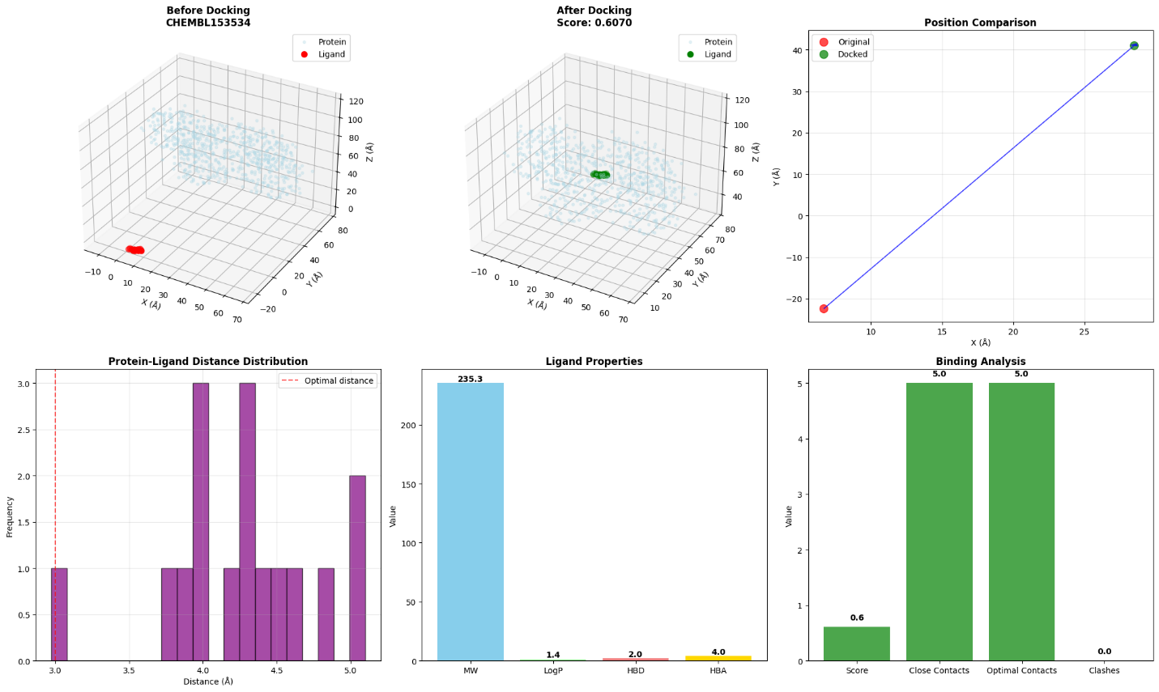
🔄 Interactive 3D Visualization for CHEMBL153534
• Docking Score: 0.6070
• Rotate and zoom to explore the binding site
✅ Docking completed - Score: 0.6070

💊 Docking CHEMBL1862084
SMILES: COc1cc(CNCc2coc(-c3cccc(F)c3)n2)cc(OC)c1...
MW: 342.4
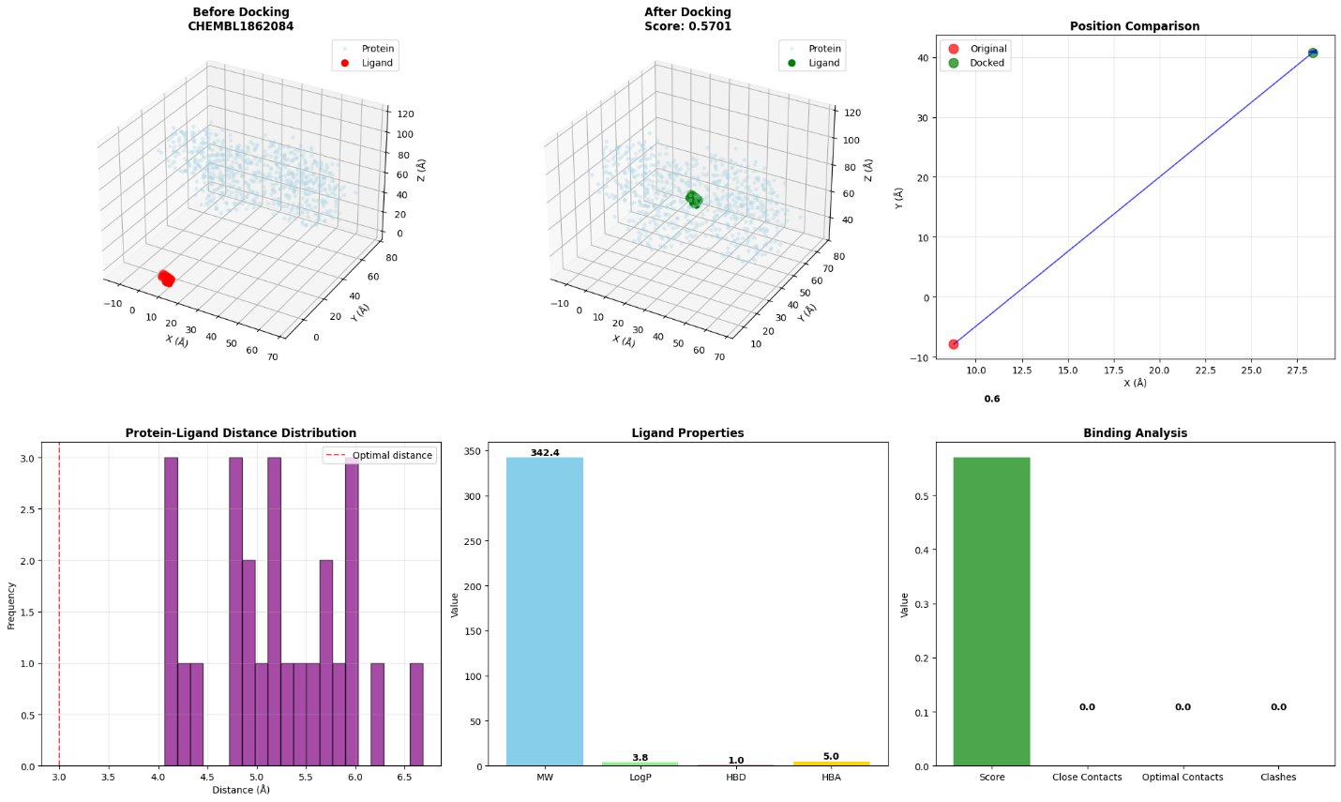
🔄 Interactive 3D Visualization for CHEMBL1862084
• Docking Score: 0.5701
• Rotate and zoom to explore the binding site
✅ Docking completed - Score: 0.5701

💊 Docking CHEMBL1382834
SMILES: COc1ccc2cc(/C=C3\SC(=S)NC3=O)c(N3CCOCC3)nc2c1...
MW: 387.5
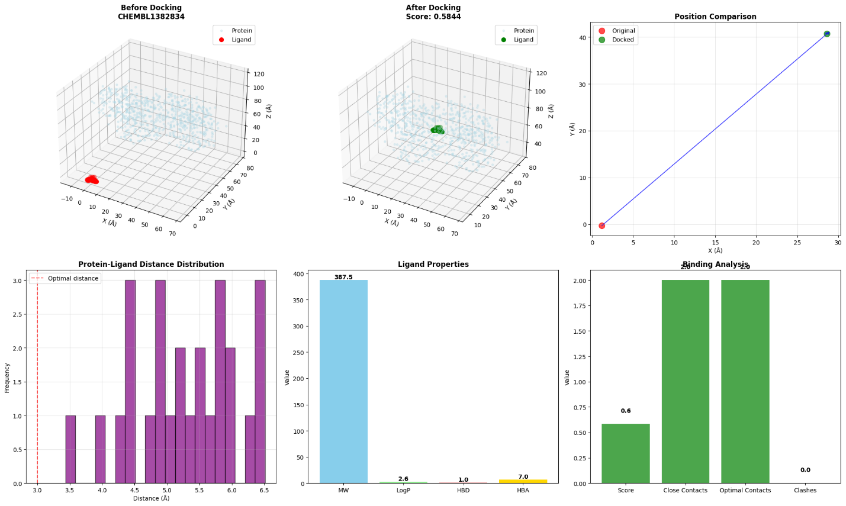
🔄 Interactive 3D Visualization for CHEMBL1382834
• Docking Score: 0.5844
• Rotate and zoom to explore the binding site
✅ Docking completed - Score: 0.5844

💊 Docking CHEMBL2430319
SMILES: CCc1ccc(Cc2cn([C@@H]3O[C@H](CO)[C@@H](O)[C@H](O)[C...
MW: 397.5
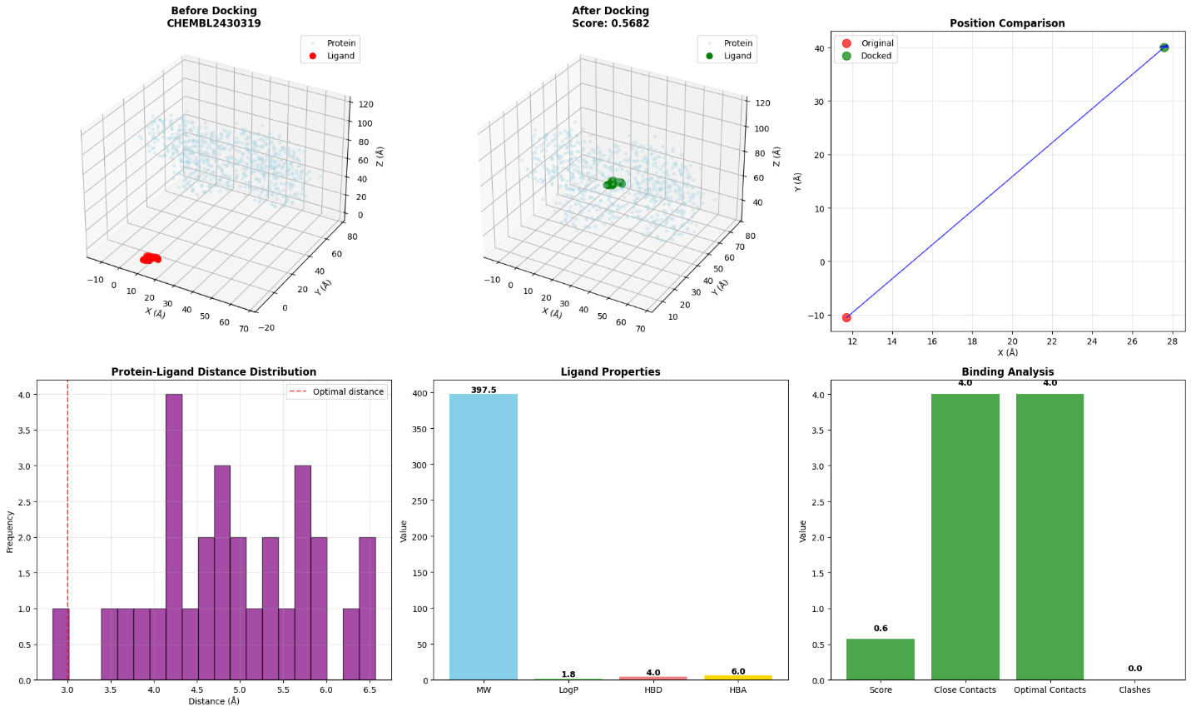
🔄 Interactive 3D Visualization for CHEMBL2430319
• Docking Score: 0.5682
• Rotate and zoom to explore the binding site
2025-09-28 22:13:54,545 - INFO - 📁 Loading protein: 1a3w
✅ Docking completed - Score: 0.5682

🔬 ANALYZING: 1a3w + chembl_33
============================================================
2025-09-28 22:13:54,780 - INFO - ✅ Protein loaded successfully:
2025-09-28 22:13:54,781 - INFO - • Atoms: 7519
2025-09-28 22:13:54,783 - INFO - • Center: [ 21.44532212 -15.0665643 25.09600412]
2025-09-28 22:13:54,784 - INFO - • Radius: 55.06 Å
2025-09-28 22:13:54,786 - INFO - • Residues: 492
2025-09-28 22:13:54,787 - INFO - 📁 Loading ligands from: chembl_33.sdf
[22:14:04] Both bonds on one end of an atropisomer are on the same side - atoms is : 6
[22:14:09] Explicit valence for atom # 0 P, 7, is greater than permitted
[22:14:09] ERROR: Could not sanitize molecule ending on line 2985308
[22:14:09] ERROR: Explicit valence for atom # 0 P, 7, is greater than permitted
[22:14:13] Explicit valence for atom # 1 P, 7, is greater than permitted
[22:14:13] ERROR: Could not sanitize molecule ending on line 3747292
[22:14:13] ERROR: Explicit valence for atom # 1 P, 7, is greater than permitted
[22:14:14] Explicit valence for atom # 1 P, 7, is greater than permitted
[22:14:14] ERROR: Could not sanitize molecule ending on line 3912696
[22:14:14] ERROR: Explicit valence for atom # 1 P, 7, is greater than permitted
[22:14:16] Warning: ambiguous stereochemistry - opposing bonds have opposite wedging - at atom 10 ignored.
[22:14:16] Warning: ambiguous stereochemistry - opposing bonds have opposite wedging - at atom 10 ignored.
[22:14:39] Warning: conflicting stereochemistry - bond wedging contradiction - at atom 48 ignored
[22:14:39] Warning: conflicting stereochemistry - bond wedging contradiction - at atom 48 ignored
[22:15:12] Both bonds on one end of an atropisomer are on the same side - atoms is : 7
[22:15:16] Both bonds on one end of an atropisomer are on the same side - atoms is : 3
[22:15:57] Warning: ambiguous stereochemistry - opposing bonds have opposite wedging - at atom 0 ignored.
[22:15:57] Warning: ambiguous stereochemistry - opposing bonds have opposite wedging - at atom 0 ignored.
[22:16:49] Warning: ambiguous stereochemistry - opposing bonds have opposite wedging - at atom 4 ignored.
[22:16:49] Warning: ambiguous stereochemistry - opposing bonds have opposite wedging - at atom 4 ignored.
[22:19:19] Warning: ambiguous stereochemistry - zero final chiral volume - at atom 6 ignored
[22:19:22] Warning: ambiguous stereochemistry - zero final chiral volume - at atom 7 ignored
[22:19:22] Warning: ambiguous stereochemistry - zero final chiral volume - at atom 13 ignored
[22:19:24] Warning: ambiguous stereochemistry - zero final chiral volume - at atom 9 ignored
[22:19:28] Warning: ambiguous stereochemistry - zero final chiral volume - at atom 6 ignored
[22:19:30] Warning: ambiguous stereochemistry - zero final chiral volume - at atom 7 ignored
[22:19:37] Warning: ambiguous stereochemistry - zero final chiral volume - at atom 5 ignored
[22:19:37] Warning: ambiguous stereochemistry - zero final chiral volume - at atom 6 ignored
[22:19:37] Warning: ambiguous stereochemistry - zero final chiral volume - at atom 5 ignored
[22:19:38] Warning: ambiguous stereochemistry - zero final chiral volume - at atom 6 ignored
[22:19:40] Warning: ambiguous stereochemistry - zero final chiral volume - at atom 278 ignored
[22:20:15] Warning: ambiguous stereochemistry - opposing bonds have opposite wedging - at atom 0 ignored.
[22:20:15] Warning: ambiguous stereochemistry - opposing bonds have opposite wedging - at atom 0 ignored.
[22:20:25] Explicit valence for atom # 0 P, 7, is greater than permitted
[22:20:25] ERROR: Could not sanitize molecule ending on line 71633591
[22:20:25] ERROR: Explicit valence for atom # 0 P, 7, is greater than permitted
[22:20:25] Explicit valence for atom # 0 P, 7, is greater than permitted
[22:20:25] ERROR: Could not sanitize molecule ending on line 71647070
[22:20:25] ERROR: Explicit valence for atom # 0 P, 7, is greater than permitted
[22:20:26] Explicit valence for atom # 0 P, 7, is greater than permitted
[22:20:26] ERROR: Could not sanitize molecule ending on line 71806725
[22:20:26] ERROR: Explicit valence for atom # 0 P, 7, is greater than permitted
[22:20:34] Explicit valence for atom # 0 P, 7, is greater than permitted
[22:20:34] ERROR: Could not sanitize molecule ending on line 72643050
[22:20:34] ERROR: Explicit valence for atom # 0 P, 7, is greater than permitted
[22:20:39] Warning: ambiguous stereochemistry - zero final chiral volume - at atom 5 ignored
[22:20:39] Warning: ambiguous stereochemistry - zero final chiral volume - at atom 6 ignored
[22:20:40] Warning: ambiguous stereochemistry - zero final chiral volume - at atom 6 ignored
[22:20:47] Warning: ambiguous stereochemistry - zero final chiral volume - at atom 10 ignored
[22:20:47] Warning: ambiguous stereochemistry - zero final chiral volume - at atom 13 ignored
[22:20:48] Warning: ambiguous stereochemistry - zero final chiral volume - at atom 4 ignored
[22:20:56] Warning: ambiguous stereochemistry - zero final chiral volume - at atom 6 ignored
[22:20:57] Warning: ambiguous stereochemistry - zero final chiral volume - at atom 10 ignored
[22:20:58] Warning: ambiguous stereochemistry - zero final chiral volume - at atom 22 ignored
[22:20:59] Warning: ambiguous stereochemistry - zero final chiral volume - at atom 6 ignored
[22:21:02] Warning: ambiguous stereochemistry - zero final chiral volume - at atom 14 ignored
[22:21:03] Warning: ambiguous stereochemistry - zero final chiral volume - at atom 5 ignored
[22:21:03] Warning: ambiguous stereochemistry - zero final chiral volume - at atom 5 ignored
[22:21:03] Warning: ambiguous stereochemistry - zero final chiral volume - at atom 5 ignored
[22:21:03] Warning: ambiguous stereochemistry - zero final chiral volume - at atom 6 ignored
[22:21:07] Warning: ambiguous stereochemistry - zero final chiral volume - at atom 1 ignored
[22:21:08] Warning: ambiguous stereochemistry - zero final chiral volume - at atom 5 ignored
[22:21:08] Warning: ambiguous stereochemistry - zero final chiral volume - at atom 6 ignored
[22:21:09] Warning: ambiguous stereochemistry - zero final chiral volume - at atom 7 ignored
[22:21:09] Warning: ambiguous stereochemistry - zero final chiral volume - at atom 13 ignored
[22:21:15] Warning: ambiguous stereochemistry - zero final chiral volume - at atom 6 ignored
[22:21:18] Warning: ambiguous stereochemistry - zero final chiral volume - at atom 14 ignored
[22:21:18] Warning: ambiguous stereochemistry - zero final chiral volume - at atom 9 ignored
[22:21:18] Warning: ambiguous stereochemistry - zero final chiral volume - at atom 7 ignored
[22:21:19] Warning: ambiguous stereochemistry - zero final chiral volume - at atom 14 ignored
[22:21:19] Warning: ambiguous stereochemistry - zero final chiral volume - at atom 18 ignored
[22:21:22] Warning: ambiguous stereochemistry - zero final chiral volume - at atom 7 ignored
[22:21:25] Warning: ambiguous stereochemistry - zero final chiral volume - at atom 5 ignored
[22:21:27] Warning: ambiguous stereochemistry - zero final chiral volume - at atom 6 ignored
[22:21:30] Warning: ambiguous stereochemistry - zero final chiral volume - at atom 5 ignored
[22:21:30] Warning: ambiguous stereochemistry - zero final chiral volume - at atom 10 ignored
[22:21:30] Warning: ambiguous stereochemistry - zero final chiral volume - at atom 5 ignored
[22:21:30] Warning: ambiguous stereochemistry - zero final chiral volume - at atom 6 ignored
[22:21:31] Warning: ambiguous stereochemistry - zero final chiral volume - at atom 6 ignored
[22:21:31] Warning: ambiguous stereochemistry - zero final chiral volume - at atom 5 ignored
[22:21:33] Warning: ambiguous stereochemistry - zero final chiral volume - at atom 5 ignored
[22:21:33] Warning: ambiguous stereochemistry - zero final chiral volume - at atom 14 ignored
[22:21:34] Warning: ambiguous stereochemistry - zero final chiral volume - at atom 6 ignored
[22:21:35] Warning: ambiguous stereochemistry - zero final chiral volume - at atom 7 ignored
[22:21:36] Warning: ambiguous stereochemistry - zero final chiral volume - at atom 9 ignored
[22:21:36] Warning: ambiguous stereochemistry - zero final chiral volume - at atom 15 ignored
[22:21:38] Warning: ambiguous stereochemistry - zero final chiral volume - at atom 16 ignored
[22:21:38] Warning: ambiguous stereochemistry - zero final chiral volume - at atom 22 ignored
[22:21:41] Warning: ambiguous stereochemistry - zero final chiral volume - at atom 5 ignored
[22:21:43] Warning: ambiguous stereochemistry - zero final chiral volume - at atom 8 ignored
[22:21:44] Warning: ambiguous stereochemistry - zero final chiral volume - at atom 5 ignored
[22:21:45] Warning: ambiguous stereochemistry - zero final chiral volume - at atom 14 ignored
[22:21:45] Warning: ambiguous stereochemistry - zero final chiral volume - at atom 10 ignored
[22:21:45] Warning: ambiguous stereochemistry - zero final chiral volume - at atom 12 ignored
[22:21:49] Warning: ambiguous stereochemistry - zero final chiral volume - at atom 5 ignored
[22:21:49] Warning: ambiguous stereochemistry - zero final chiral volume - at atom 5 ignored
[22:21:49] Warning: ambiguous stereochemistry - zero final chiral volume - at atom 6 ignored
[22:21:49] Warning: ambiguous stereochemistry - zero final chiral volume - at atom 15 ignored
[22:21:52] Warning: ambiguous stereochemistry - zero final chiral volume - at atom 17 ignored
[22:21:55] Warning: ambiguous stereochemistry - zero final chiral volume - at atom 6 ignored
[22:21:56] Warning: ambiguous stereochemistry - zero final chiral volume - at atom 7 ignored
[22:21:57] Warning: ambiguous stereochemistry - zero final chiral volume - at atom 5 ignored
[22:21:57] Warning: ambiguous stereochemistry - zero final chiral volume - at atom 11 ignored
[22:21:57] Warning: ambiguous stereochemistry - zero final chiral volume - at atom 16 ignored
[22:21:58] Warning: ambiguous stereochemistry - zero final chiral volume - at atom 6 ignored
[22:22:01] Warning: ambiguous stereochemistry - zero final chiral volume - at atom 11 ignored
[22:22:05] Explicit valence for atom # 0 P, 7, is greater than permitted
[22:22:05] ERROR: Could not sanitize molecule ending on line 88494481
[22:22:05] ERROR: Explicit valence for atom # 0 P, 7, is greater than permitted
[22:22:05] Explicit valence for atom # 0 P, 7, is greater than permitted
[22:22:05] ERROR: Could not sanitize molecule ending on line 88559881
[22:22:05] ERROR: Explicit valence for atom # 0 P, 7, is greater than permitted
[22:22:08] Explicit valence for atom # 0 P, 7, is greater than permitted
[22:22:08] ERROR: Could not sanitize molecule ending on line 89021973
[22:22:08] ERROR: Explicit valence for atom # 0 P, 7, is greater than permitted
[22:22:40] Warning: ambiguous stereochemistry - zero final chiral volume - at atom 25 ignored
[22:23:46] Warning: ambiguous stereochemistry - zero final chiral volume - at atom 48 ignored
[22:24:01] Warning: ambiguous stereochemistry - zero final chiral volume - at atom 44 ignored
[22:24:24] The bonds on one end of an atropisomer are both UP or both DOWN - atoms are: 0 20
[22:25:13] Warning: ambiguous stereochemistry - zero final chiral volume - at atom 151 ignored
[22:25:13] Warning: ambiguous stereochemistry - zero final chiral volume - at atom 151 ignored
[22:25:13] Warning: ambiguous stereochemistry - zero final chiral volume - at atom 151 ignored
[22:25:13] Warning: ambiguous stereochemistry - zero final chiral volume - at atom 151 ignored
[22:25:13] Warning: ambiguous stereochemistry - zero final chiral volume - at atom 152 ignored
[22:25:14] Warning: ambiguous stereochemistry - zero final chiral volume - at atom 60 ignored
[22:25:14] Warning: ambiguous stereochemistry - zero final chiral volume - at atom 65 ignored
[22:25:15] Warning: ambiguous stereochemistry - overlapping neighbors - at atom 9 ignored
[22:25:15] Warning: ambiguous stereochemistry - overlapping neighbors - at atom 10 ignored
[22:25:16] Warning: ambiguous stereochemistry - overlapping neighbors - at atom 13 ignored
[22:25:16] Warning: ambiguous stereochemistry - overlapping neighbors - at atom 21 ignored
[22:25:16] Warning: ambiguous stereochemistry - zero final chiral volume - at atom 50 ignored
[22:25:16] Warning: ambiguous stereochemistry - zero final chiral volume - at atom 52 ignored
[22:25:16] Warning: ambiguous stereochemistry - zero final chiral volume - at atom 48 ignored
[22:25:16] Warning: ambiguous stereochemistry - overlapping neighbors - at atom 9 ignored
[22:25:16] Warning: ambiguous stereochemistry - overlapping neighbors - at atom 15 ignored
[22:25:16] Warning: ambiguous stereochemistry - overlapping neighbors - at atom 16 ignored
[22:25:16] Warning: ambiguous stereochemistry - zero final chiral volume - at atom 17 ignored
[22:25:16] Warning: ambiguous stereochemistry - zero final chiral volume - at atom 23 ignored
[22:25:16] Warning: ambiguous stereochemistry - zero final chiral volume - at atom 17 ignored
[22:25:16] Warning: ambiguous stereochemistry - zero final chiral volume - at atom 23 ignored
[22:25:16] Warning: ambiguous stereochemistry - overlapping neighbors - at atom 10 ignored
[22:25:16] Warning: ambiguous stereochemistry - overlapping neighbors - at atom 9 ignored
[22:25:17] Warning: ambiguous stereochemistry - overlapping neighbors - at atom 9 ignored
[22:25:17] Warning: ambiguous stereochemistry - overlapping neighbors - at atom 10 ignored
[22:25:17] Warning: ambiguous stereochemistry - overlapping neighbors - at atom 10 ignored
[22:25:17] Warning: ambiguous stereochemistry - overlapping neighbors - at atom 9 ignored
[22:25:17] Warning: ambiguous stereochemistry - overlapping neighbors - at atom 10 ignored
[22:25:17] Warning: ambiguous stereochemistry - overlapping neighbors - at atom 4 ignored
[22:25:17] Warning: ambiguous stereochemistry - overlapping neighbors - at atom 13 ignored
[22:25:17] Warning: ambiguous stereochemistry - overlapping neighbors - at atom 9 ignored
[22:25:17] Warning: ambiguous stereochemistry - zero final chiral volume - at atom 15 ignored
[22:25:17] Warning: ambiguous stereochemistry - zero final chiral volume - at atom 54 ignored
[22:25:17] Warning: ambiguous stereochemistry - zero final chiral volume - at atom 46 ignored
[22:25:17] Warning: ambiguous stereochemistry - zero final chiral volume - at atom 77 ignored
[22:25:18] Warning: ambiguous stereochemistry - zero final chiral volume - at atom 23 ignored
[22:25:18] Warning: ambiguous stereochemistry - zero final chiral volume - at atom 24 ignored
[22:25:18] Warning: ambiguous stereochemistry - zero final chiral volume - at atom 56 ignored
[22:25:18] Warning: ambiguous stereochemistry - overlapping neighbors - at atom 13 ignored
[22:25:18] Warning: ambiguous stereochemistry - overlapping neighbors - at atom 12 ignored
[22:25:18] Warning: ambiguous stereochemistry - zero final chiral volume - at atom 6 ignored
[22:25:18] Warning: ambiguous stereochemistry - zero final chiral volume - at atom 43 ignored
[22:25:18] Warning: ambiguous stereochemistry - zero final chiral volume - at atom 56 ignored
[22:25:18] Warning: ambiguous stereochemistry - zero final chiral volume - at atom 65 ignored
[22:25:18] Warning: ambiguous stereochemistry - overlapping neighbors - at atom 10 ignored
[22:25:18] Warning: ambiguous stereochemistry - overlapping neighbors - at atom 9 ignored
[22:25:18] Warning: ambiguous stereochemistry - overlapping neighbors - at atom 10 ignored
[22:25:44] Warning: ambiguous stereochemistry - zero final chiral volume - at atom 151 ignored
[22:25:44] Warning: ambiguous stereochemistry - zero final chiral volume - at atom 151 ignored
[22:25:46] Both bonds on one end of an atropisomer are on the same side - atoms is : 0
[22:25:46] Both bonds on one end of an atropisomer are on the same side - atoms is : 2
[22:26:03] Warning: ambiguous stereochemistry - opposing bonds have opposite wedging - at atom 0 ignored.
[22:26:03] Warning: ambiguous stereochemistry - opposing bonds have opposite wedging - at atom 0 ignored.
[22:26:05] Warning: ambiguous stereochemistry - overlapping neighbors - at atom 17 ignored
[22:26:05] Warning: ambiguous stereochemistry - zero final chiral volume - at atom 14 ignored
[22:26:05] Warning: ambiguous stereochemistry - zero final chiral volume - at atom 14 ignored
[22:26:18] Warning: ambiguous stereochemistry - opposing bonds have opposite wedging - at atom 6 ignored.
[22:26:18] Warning: ambiguous stereochemistry - opposing bonds have opposite wedging - at atom 6 ignored.
[22:26:18] Warning: ambiguous stereochemistry - opposing bonds have opposite wedging - at atom 11 ignored.
[22:26:18] Warning: ambiguous stereochemistry - opposing bonds have opposite wedging - at atom 11 ignored.
[22:26:42] Warning: ambiguous stereochemistry - zero final chiral volume - at atom 273 ignored
[22:26:42] Warning: ambiguous stereochemistry - zero final chiral volume - at atom 273 ignored
[22:26:43] Warning: ambiguous stereochemistry - overlapping neighbors - at atom 5 ignored
[22:26:43] Warning: ambiguous stereochemistry - overlapping neighbors - at atom 8 ignored
[22:26:43] Warning: ambiguous stereochemistry - overlapping neighbors - at atom 2 ignored
[22:26:43] Warning: ambiguous stereochemistry - overlapping neighbors - at atom 3 ignored
[22:26:44] Warning: ambiguous stereochemistry - overlapping neighbors - at atom 5 ignored
[22:26:44] Warning: ambiguous stereochemistry - overlapping neighbors - at atom 8 ignored
[22:26:44] Warning: ambiguous stereochemistry - overlapping neighbors - at atom 2 ignored
[22:26:44] Warning: ambiguous stereochemistry - overlapping neighbors - at atom 3 ignored
[22:26:44] Warning: ambiguous stereochemistry - overlapping neighbors - at atom 21 ignored
[22:26:44] Warning: ambiguous stereochemistry - overlapping neighbors - at atom 19 ignored
[22:27:04] Warning: ambiguous stereochemistry - zero final chiral volume - at atom 28 ignored
[22:27:14] Warning: ambiguous stereochemistry - overlapping neighbors - at atom 37 ignored
[22:27:17] Warning: ambiguous stereochemistry - overlapping neighbors - at atom 1 ignored
[22:27:20] Warning: ambiguous stereochemistry - overlapping neighbors - at atom 15 ignored
[22:27:20] Warning: ambiguous stereochemistry - overlapping neighbors - at atom 15 ignored
[22:27:20] Warning: ambiguous stereochemistry - overlapping neighbors - at atom 10 ignored
[22:27:20] Warning: ambiguous stereochemistry - overlapping neighbors - at atom 12 ignored
[22:27:20] Warning: ambiguous stereochemistry - overlapping neighbors - at atom 15 ignored
[22:27:21] Warning: ambiguous stereochemistry - overlapping neighbors - at atom 15 ignored
[22:27:21] Warning: ambiguous stereochemistry - overlapping neighbors - at atom 12 ignored
[22:27:21] Warning: ambiguous stereochemistry - overlapping neighbors - at atom 15 ignored
[22:27:21] Warning: ambiguous stereochemistry - overlapping neighbors - at atom 4 ignored
[22:27:21] Warning: ambiguous stereochemistry - overlapping neighbors - at atom 29 ignored
[22:27:21] Warning: ambiguous stereochemistry - overlapping neighbors - at atom 32 ignored
[22:27:21] Warning: ambiguous stereochemistry - overlapping neighbors - at atom 7 ignored
[22:27:21] Warning: ambiguous stereochemistry - overlapping neighbors - at atom 12 ignored
[22:27:21] Warning: ambiguous stereochemistry - overlapping neighbors - at atom 15 ignored
[22:27:21] Warning: ambiguous stereochemistry - overlapping neighbors - at atom 12 ignored
[22:27:21] Warning: ambiguous stereochemistry - overlapping neighbors - at atom 15 ignored
[22:27:21] Warning: ambiguous stereochemistry - overlapping neighbors - at atom 12 ignored
[22:27:21] Warning: ambiguous stereochemistry - overlapping neighbors - at atom 15 ignored
[22:27:22] Warning: ambiguous stereochemistry - overlapping neighbors - at atom 4 ignored
[22:27:22] Warning: ambiguous stereochemistry - overlapping neighbors - at atom 29 ignored
[22:27:22] Warning: ambiguous stereochemistry - overlapping neighbors - at atom 32 ignored
[22:27:22] Warning: ambiguous stereochemistry - overlapping neighbors - at atom 7 ignored
[22:27:25] Warning: ambiguous stereochemistry - overlapping neighbors - at atom 2 ignored
[22:27:26] Warning: ambiguous stereochemistry - overlapping neighbors - at atom 2 ignored
[22:27:26] Warning: ambiguous stereochemistry - overlapping neighbors - at atom 2 ignored
[22:27:26] Warning: ambiguous stereochemistry - overlapping neighbors - at atom 2 ignored
[22:27:26] Warning: ambiguous stereochemistry - overlapping neighbors - at atom 2 ignored
[22:27:26] Warning: ambiguous stereochemistry - overlapping neighbors - at atom 2 ignored
[22:27:26] Warning: ambiguous stereochemistry - overlapping neighbors - at atom 2 ignored
[22:27:27] Warning: ambiguous stereochemistry - zero final chiral volume - at atom 42 ignored
[22:27:27] Warning: ambiguous stereochemistry - zero final chiral volume - at atom 129 ignored
[22:27:27] Warning: ambiguous stereochemistry - zero final chiral volume - at atom 123 ignored
[22:27:27] Warning: ambiguous stereochemistry - zero final chiral volume - at atom 122 ignored
[22:27:27] Warning: ambiguous stereochemistry - zero final chiral volume - at atom 141 ignored
[22:27:27] Warning: ambiguous stereochemistry - zero final chiral volume - at atom 69 ignored
[22:27:27] Warning: ambiguous stereochemistry - zero final chiral volume - at atom 46 ignored
[22:27:27] Warning: ambiguous stereochemistry - zero final chiral volume - at atom 63 ignored
[22:27:27] Warning: ambiguous stereochemistry - zero final chiral volume - at atom 98 ignored
[22:27:27] Warning: ambiguous stereochemistry - zero final chiral volume - at atom 120 ignored
[22:27:27] Warning: ambiguous stereochemistry - zero final chiral volume - at atom 72 ignored
[22:27:27] Warning: ambiguous stereochemistry - zero final chiral volume - at atom 130 ignored
[22:27:27] Warning: ambiguous stereochemistry - overlapping neighbors - at atom 2 ignored
[22:27:55] Warning: ambiguous stereochemistry - overlapping neighbors - at atom 4 ignored
[22:27:56] Warning: ambiguous stereochemistry - overlapping neighbors - at atom 12 ignored
[22:27:56] Warning: ambiguous stereochemistry - overlapping neighbors - at atom 32 ignored
[22:27:56] Warning: ambiguous stereochemistry - overlapping neighbors - at atom 20 ignored
[22:27:56] Warning: ambiguous stereochemistry - overlapping neighbors - at atom 17 ignored
[22:27:59] Warning: ambiguous stereochemistry - overlapping neighbors - at atom 6 ignored
[22:27:59] Warning: ambiguous stereochemistry - overlapping neighbors - at atom 6 ignored
[22:27:59] Warning: ambiguous stereochemistry - overlapping neighbors - at atom 6 ignored
[22:27:59] Warning: ambiguous stereochemistry - overlapping neighbors - at atom 6 ignored
[22:27:59] Warning: ambiguous stereochemistry - overlapping neighbors - at atom 6 ignored
[22:27:59] Warning: ambiguous stereochemistry - overlapping neighbors - at atom 6 ignored
[22:28:00] Warning: ambiguous stereochemistry - overlapping neighbors - at atom 6 ignored
[22:28:00] Warning: ambiguous stereochemistry - overlapping neighbors - at atom 16 ignored
[22:28:03] Warning: ambiguous stereochemistry - overlapping neighbors - at atom 1 ignored
[22:28:03] Warning: ambiguous stereochemistry - overlapping neighbors - at atom 3 ignored
[22:28:03] Warning: ambiguous stereochemistry - overlapping neighbors - at atom 14 ignored
[22:28:03] Warning: ambiguous stereochemistry - overlapping neighbors - at atom 14 ignored
[22:28:03] Warning: ambiguous stereochemistry - overlapping neighbors - at atom 14 ignored
[22:28:03] Warning: ambiguous stereochemistry - overlapping neighbors - at atom 3 ignored
[22:28:03] Warning: ambiguous stereochemistry - overlapping neighbors - at atom 3 ignored
[22:28:03] Warning: ambiguous stereochemistry - overlapping neighbors - at atom 3 ignored
[22:28:03] Warning: ambiguous stereochemistry - overlapping neighbors - at atom 14 ignored
[22:28:03] Warning: ambiguous stereochemistry - overlapping neighbors - at atom 13 ignored
[22:28:03] Warning: ambiguous stereochemistry - overlapping neighbors - at atom 14 ignored
[22:28:03] Warning: ambiguous stereochemistry - overlapping neighbors - at atom 14 ignored
[22:28:03] Warning: ambiguous stereochemistry - overlapping neighbors - at atom 3 ignored
[22:28:03] Warning: ambiguous stereochemistry - overlapping neighbors - at atom 3 ignored
[22:28:03] Warning: ambiguous stereochemistry - overlapping neighbors - at atom 3 ignored
[22:28:03] Warning: ambiguous stereochemistry - overlapping neighbors - at atom 3 ignored
[22:28:03] Warning: ambiguous stereochemistry - overlapping neighbors - at atom 3 ignored
[22:28:04] Warning: ambiguous stereochemistry - overlapping neighbors - at atom 3 ignored
[22:28:04] Warning: ambiguous stereochemistry - overlapping neighbors - at atom 3 ignored
[22:28:04] Warning: ambiguous stereochemistry - overlapping neighbors - at atom 14 ignored
[22:28:04] Warning: ambiguous stereochemistry - overlapping neighbors - at atom 14 ignored
[22:28:04] Warning: ambiguous stereochemistry - overlapping neighbors - at atom 14 ignored
[22:28:04] Warning: ambiguous stereochemistry - overlapping neighbors - at atom 3 ignored
[22:28:04] Warning: ambiguous stereochemistry - overlapping neighbors - at atom 3 ignored
[22:28:04] Warning: ambiguous stereochemistry - overlapping neighbors - at atom 3 ignored
[22:28:04] Warning: ambiguous stereochemistry - overlapping neighbors - at atom 3 ignored
[22:28:05] Warning: ambiguous stereochemistry - overlapping neighbors - at atom 14 ignored
[22:28:05] Warning: ambiguous stereochemistry - overlapping neighbors - at atom 14 ignored
[22:28:05] Warning: ambiguous stereochemistry - overlapping neighbors - at atom 42 ignored
[22:28:05] Warning: ambiguous stereochemistry - overlapping neighbors - at atom 14 ignored
[22:28:06] Warning: ambiguous stereochemistry - overlapping neighbors - at atom 6 ignored
[22:28:06] Warning: ambiguous stereochemistry - overlapping neighbors - at atom 14 ignored
[22:28:06] Warning: ambiguous stereochemistry - overlapping neighbors - at atom 8 ignored
[22:28:06] Warning: ambiguous stereochemistry - overlapping neighbors - at atom 0 ignored
[22:28:09] Warning: ambiguous stereochemistry - overlapping neighbors - at atom 12 ignored
[22:28:09] Warning: ambiguous stereochemistry - overlapping neighbors - at atom 3 ignored
[22:28:11] Warning: ambiguous stereochemistry - overlapping neighbors - at atom 7 ignored
[22:28:11] Warning: ambiguous stereochemistry - overlapping neighbors - at atom 6 ignored
[22:29:37] Both bonds on one end of an atropisomer are on the same side - atoms is : 2
[22:29:42] Warning: ambiguous stereochemistry - zero final chiral volume - at atom 123 ignored
[22:29:43] Explicit valence for atom # 0 As, 7, is greater than permitted
[22:29:43] ERROR: Could not sanitize molecule ending on line 173161130
[22:29:43] ERROR: Explicit valence for atom # 0 As, 7, is greater than permitted
[22:29:43] Warning: ambiguous stereochemistry - overlapping neighbors - at atom 29 ignored
[22:29:43] Explicit valence for atom # 22 P, 7, is greater than permitted
[22:29:43] ERROR: Could not sanitize molecule ending on line 173192773
[22:29:43] ERROR: Explicit valence for atom # 22 P, 7, is greater than permitted
[22:29:43] Explicit valence for atom # 0 P, 7, is greater than permitted
[22:29:43] ERROR: Could not sanitize molecule ending on line 173192963
[22:29:43] ERROR: Explicit valence for atom # 0 P, 7, is greater than permitted
2025-09-28 22:29:43,564 - INFO - 📊 Total molecules in SDF: 2372661
2025-09-28 22:29:43,567 - INFO - ✅ Sampled CHEMBL153534: MW=235.3
[22:29:53] Both bonds on one end of an atropisomer are on the same side - atoms is : 6
[22:29:59] Explicit valence for atom # 0 P, 7, is greater than permitted
[22:29:59] ERROR: Could not sanitize molecule ending on line 2985308
[22:29:59] ERROR: Explicit valence for atom # 0 P, 7, is greater than permitted
[22:30:03] Explicit valence for atom # 1 P, 7, is greater than permitted
[22:30:03] ERROR: Could not sanitize molecule ending on line 3747292
[22:30:03] ERROR: Explicit valence for atom # 1 P, 7, is greater than permitted
[22:30:04] Explicit valence for atom # 1 P, 7, is greater than permitted
[22:30:04] ERROR: Could not sanitize molecule ending on line 3912696
[22:30:04] ERROR: Explicit valence for atom # 1 P, 7, is greater than permitted
[22:30:06] Warning: ambiguous stereochemistry - opposing bonds have opposite wedging - at atom 10 ignored.
[22:30:06] Warning: ambiguous stereochemistry - opposing bonds have opposite wedging - at atom 10 ignored.
[22:30:28] Warning: conflicting stereochemistry - bond wedging contradiction - at atom 48 ignored
[22:30:28] Warning: conflicting stereochemistry - bond wedging contradiction - at atom 48 ignored
[22:31:01] Both bonds on one end of an atropisomer are on the same side - atoms is : 7
[22:31:03] Both bonds on one end of an atropisomer are on the same side - atoms is : 3
[22:31:49] Warning: ambiguous stereochemistry - opposing bonds have opposite wedging - at atom 0 ignored.
[22:31:49] Warning: ambiguous stereochemistry - opposing bonds have opposite wedging - at atom 0 ignored.
[22:32:43] Warning: ambiguous stereochemistry - opposing bonds have opposite wedging - at atom 4 ignored.
[22:32:43] Warning: ambiguous stereochemistry - opposing bonds have opposite wedging - at atom 4 ignored.
2025-09-28 22:33:32,728 - INFO - ✅ Sampled CHEMBL1862084: MW=342.4
[22:34:59] Warning: ambiguous stereochemistry - zero final chiral volume - at atom 6 ignored
[22:35:02] Warning: ambiguous stereochemistry - zero final chiral volume - at atom 7 ignored
[22:35:02] Warning: ambiguous stereochemistry - zero final chiral volume - at atom 13 ignored
[22:35:04] Warning: ambiguous stereochemistry - zero final chiral volume - at atom 9 ignored
[22:35:08] Warning: ambiguous stereochemistry - zero final chiral volume - at atom 6 ignored
[22:35:10] Warning: ambiguous stereochemistry - zero final chiral volume - at atom 7 ignored
[22:35:15] Warning: ambiguous stereochemistry - zero final chiral volume - at atom 5 ignored
[22:35:15] Warning: ambiguous stereochemistry - zero final chiral volume - at atom 6 ignored
[22:35:15] Warning: ambiguous stereochemistry - zero final chiral volume - at atom 5 ignored
[22:35:16] Warning: ambiguous stereochemistry - zero final chiral volume - at atom 6 ignored
[22:35:19] Warning: ambiguous stereochemistry - zero final chiral volume - at atom 278 ignored
[22:35:50] Warning: ambiguous stereochemistry - opposing bonds have opposite wedging - at atom 0 ignored.
[22:35:50] Warning: ambiguous stereochemistry - opposing bonds have opposite wedging - at atom 0 ignored.
[22:35:57] Explicit valence for atom # 0 P, 7, is greater than permitted
[22:35:57] ERROR: Could not sanitize molecule ending on line 71633591
[22:35:57] ERROR: Explicit valence for atom # 0 P, 7, is greater than permitted
[22:35:57] Explicit valence for atom # 0 P, 7, is greater than permitted
[22:35:57] ERROR: Could not sanitize molecule ending on line 71647070
[22:35:57] ERROR: Explicit valence for atom # 0 P, 7, is greater than permitted
[22:35:58] Explicit valence for atom # 0 P, 7, is greater than permitted
[22:35:58] ERROR: Could not sanitize molecule ending on line 71806725
[22:35:58] ERROR: Explicit valence for atom # 0 P, 7, is greater than permitted
[22:36:03] Explicit valence for atom # 0 P, 7, is greater than permitted
[22:36:03] ERROR: Could not sanitize molecule ending on line 72643050
[22:36:03] ERROR: Explicit valence for atom # 0 P, 7, is greater than permitted
[22:36:08] Warning: ambiguous stereochemistry - zero final chiral volume - at atom 5 ignored
[22:36:08] Warning: ambiguous stereochemistry - zero final chiral volume - at atom 6 ignored
[22:36:09] Warning: ambiguous stereochemistry - zero final chiral volume - at atom 6 ignored
[22:36:15] Warning: ambiguous stereochemistry - zero final chiral volume - at atom 10 ignored
[22:36:15] Warning: ambiguous stereochemistry - zero final chiral volume - at atom 13 ignored
[22:36:17] Warning: ambiguous stereochemistry - zero final chiral volume - at atom 4 ignored
[22:36:27] Warning: ambiguous stereochemistry - zero final chiral volume - at atom 6 ignored
[22:36:27] Warning: ambiguous stereochemistry - zero final chiral volume - at atom 10 ignored
[22:36:29] Warning: ambiguous stereochemistry - zero final chiral volume - at atom 22 ignored
[22:36:29] Warning: ambiguous stereochemistry - zero final chiral volume - at atom 6 ignored
[22:36:32] Warning: ambiguous stereochemistry - zero final chiral volume - at atom 14 ignored
[22:36:32] Warning: ambiguous stereochemistry - zero final chiral volume - at atom 5 ignored
[22:36:33] Warning: ambiguous stereochemistry - zero final chiral volume - at atom 5 ignored
[22:36:34] Warning: ambiguous stereochemistry - zero final chiral volume - at atom 5 ignored
[22:36:34] Warning: ambiguous stereochemistry - zero final chiral volume - at atom 6 ignored
[22:36:38] Warning: ambiguous stereochemistry - zero final chiral volume - at atom 1 ignored
[22:36:39] Warning: ambiguous stereochemistry - zero final chiral volume - at atom 5 ignored
[22:36:39] Warning: ambiguous stereochemistry - zero final chiral volume - at atom 6 ignored
[22:36:40] Warning: ambiguous stereochemistry - zero final chiral volume - at atom 7 ignored
[22:36:40] Warning: ambiguous stereochemistry - zero final chiral volume - at atom 13 ignored
[22:36:43] Warning: ambiguous stereochemistry - zero final chiral volume - at atom 6 ignored
[22:36:45] Warning: ambiguous stereochemistry - zero final chiral volume - at atom 14 ignored
[22:36:45] Warning: ambiguous stereochemistry - zero final chiral volume - at atom 9 ignored
[22:36:45] Warning: ambiguous stereochemistry - zero final chiral volume - at atom 7 ignored
[22:36:46] Warning: ambiguous stereochemistry - zero final chiral volume - at atom 14 ignored
[22:36:46] Warning: ambiguous stereochemistry - zero final chiral volume - at atom 18 ignored
[22:36:49] Warning: ambiguous stereochemistry - zero final chiral volume - at atom 7 ignored
[22:36:51] Warning: ambiguous stereochemistry - zero final chiral volume - at atom 5 ignored
[22:36:52] Warning: ambiguous stereochemistry - zero final chiral volume - at atom 6 ignored
[22:36:55] Warning: ambiguous stereochemistry - zero final chiral volume - at atom 5 ignored
[22:36:55] Warning: ambiguous stereochemistry - zero final chiral volume - at atom 10 ignored
[22:36:55] Warning: ambiguous stereochemistry - zero final chiral volume - at atom 5 ignored
[22:36:55] Warning: ambiguous stereochemistry - zero final chiral volume - at atom 6 ignored
[22:36:56] Warning: ambiguous stereochemistry - zero final chiral volume - at atom 6 ignored
[22:36:56] Warning: ambiguous stereochemistry - zero final chiral volume - at atom 5 ignored
[22:36:58] Warning: ambiguous stereochemistry - zero final chiral volume - at atom 5 ignored
[22:36:58] Warning: ambiguous stereochemistry - zero final chiral volume - at atom 14 ignored
[22:36:59] Warning: ambiguous stereochemistry - zero final chiral volume - at atom 6 ignored
[22:37:00] Warning: ambiguous stereochemistry - zero final chiral volume - at atom 7 ignored
[22:37:01] Warning: ambiguous stereochemistry - zero final chiral volume - at atom 9 ignored
[22:37:01] Warning: ambiguous stereochemistry - zero final chiral volume - at atom 15 ignored
[22:37:03] Warning: ambiguous stereochemistry - zero final chiral volume - at atom 16 ignored
[22:37:03] Warning: ambiguous stereochemistry - zero final chiral volume - at atom 22 ignored
[22:37:06] Warning: ambiguous stereochemistry - zero final chiral volume - at atom 5 ignored
[22:37:08] Warning: ambiguous stereochemistry - zero final chiral volume - at atom 8 ignored
[22:37:09] Warning: ambiguous stereochemistry - zero final chiral volume - at atom 5 ignored
[22:37:10] Warning: ambiguous stereochemistry - zero final chiral volume - at atom 14 ignored
[22:37:11] Warning: ambiguous stereochemistry - zero final chiral volume - at atom 10 ignored
[22:37:11] Warning: ambiguous stereochemistry - zero final chiral volume - at atom 12 ignored
[22:37:14] Warning: ambiguous stereochemistry - zero final chiral volume - at atom 5 ignored
[22:37:14] Warning: ambiguous stereochemistry - zero final chiral volume - at atom 5 ignored
[22:37:14] Warning: ambiguous stereochemistry - zero final chiral volume - at atom 6 ignored
[22:37:14] Warning: ambiguous stereochemistry - zero final chiral volume - at atom 15 ignored
[22:37:19] Warning: ambiguous stereochemistry - zero final chiral volume - at atom 17 ignored
[22:37:21] Warning: ambiguous stereochemistry - zero final chiral volume - at atom 6 ignored
2025-09-28 22:37:22,127 - INFO - ✅ Sampled CHEMBL1382834: MW=387.5
[22:37:22] Warning: ambiguous stereochemistry - zero final chiral volume - at atom 7 ignored
[22:37:23] Warning: ambiguous stereochemistry - zero final chiral volume - at atom 5 ignored
[22:37:23] Warning: ambiguous stereochemistry - zero final chiral volume - at atom 11 ignored
[22:37:23] Warning: ambiguous stereochemistry - zero final chiral volume - at atom 16 ignored
[22:37:24] Warning: ambiguous stereochemistry - zero final chiral volume - at atom 6 ignored
[22:37:27] Warning: ambiguous stereochemistry - zero final chiral volume - at atom 11 ignored
[22:37:31] Explicit valence for atom # 0 P, 7, is greater than permitted
[22:37:31] ERROR: Could not sanitize molecule ending on line 88494481
[22:37:31] ERROR: Explicit valence for atom # 0 P, 7, is greater than permitted
[22:37:32] Explicit valence for atom # 0 P, 7, is greater than permitted
[22:37:32] ERROR: Could not sanitize molecule ending on line 88559881
[22:37:32] ERROR: Explicit valence for atom # 0 P, 7, is greater than permitted
[22:37:34] Explicit valence for atom # 0 P, 7, is greater than permitted
[22:37:34] ERROR: Could not sanitize molecule ending on line 89021973
[22:37:34] ERROR: Explicit valence for atom # 0 P, 7, is greater than permitted
[22:38:07] Warning: ambiguous stereochemistry - zero final chiral volume - at atom 25 ignored
[22:39:14] Warning: ambiguous stereochemistry - zero final chiral volume - at atom 48 ignored
[22:39:29] Warning: ambiguous stereochemistry - zero final chiral volume - at atom 44 ignored
[22:39:51] The bonds on one end of an atropisomer are both UP or both DOWN - atoms are: 0 20
[22:40:37] Warning: ambiguous stereochemistry - zero final chiral volume - at atom 151 ignored
[22:40:37] Warning: ambiguous stereochemistry - zero final chiral volume - at atom 151 ignored
[22:40:37] Warning: ambiguous stereochemistry - zero final chiral volume - at atom 151 ignored
[22:40:37] Warning: ambiguous stereochemistry - zero final chiral volume - at atom 151 ignored
[22:40:37] Warning: ambiguous stereochemistry - zero final chiral volume - at atom 152 ignored
[22:40:38] Warning: ambiguous stereochemistry - zero final chiral volume - at atom 60 ignored
[22:40:38] Warning: ambiguous stereochemistry - zero final chiral volume - at atom 65 ignored
[22:40:40] Warning: ambiguous stereochemistry - overlapping neighbors - at atom 9 ignored
[22:40:40] Warning: ambiguous stereochemistry - overlapping neighbors - at atom 10 ignored
[22:40:40] Warning: ambiguous stereochemistry - overlapping neighbors - at atom 13 ignored
[22:40:40] Warning: ambiguous stereochemistry - overlapping neighbors - at atom 21 ignored
[22:40:40] Warning: ambiguous stereochemistry - zero final chiral volume - at atom 50 ignored
[22:40:40] Warning: ambiguous stereochemistry - zero final chiral volume - at atom 52 ignored
[22:40:41] Warning: ambiguous stereochemistry - zero final chiral volume - at atom 48 ignored
[22:40:41] Warning: ambiguous stereochemistry - overlapping neighbors - at atom 9 ignored
[22:40:41] Warning: ambiguous stereochemistry - overlapping neighbors - at atom 15 ignored
[22:40:41] Warning: ambiguous stereochemistry - overlapping neighbors - at atom 16 ignored
[22:40:41] Warning: ambiguous stereochemistry - zero final chiral volume - at atom 17 ignored
[22:40:41] Warning: ambiguous stereochemistry - zero final chiral volume - at atom 23 ignored
[22:40:41] Warning: ambiguous stereochemistry - zero final chiral volume - at atom 17 ignored
[22:40:41] Warning: ambiguous stereochemistry - zero final chiral volume - at atom 23 ignored
[22:40:41] Warning: ambiguous stereochemistry - overlapping neighbors - at atom 10 ignored
[22:40:41] Warning: ambiguous stereochemistry - overlapping neighbors - at atom 9 ignored
[22:40:41] Warning: ambiguous stereochemistry - overlapping neighbors - at atom 9 ignored
[22:40:41] Warning: ambiguous stereochemistry - overlapping neighbors - at atom 10 ignored
[22:40:41] Warning: ambiguous stereochemistry - overlapping neighbors - at atom 10 ignored
[22:40:41] Warning: ambiguous stereochemistry - overlapping neighbors - at atom 9 ignored
[22:40:41] Warning: ambiguous stereochemistry - overlapping neighbors - at atom 10 ignored
[22:40:41] Warning: ambiguous stereochemistry - overlapping neighbors - at atom 4 ignored
[22:40:42] Warning: ambiguous stereochemistry - overlapping neighbors - at atom 13 ignored
[22:40:42] Warning: ambiguous stereochemistry - overlapping neighbors - at atom 9 ignored
[22:40:42] Warning: ambiguous stereochemistry - zero final chiral volume - at atom 15 ignored
[22:40:42] Warning: ambiguous stereochemistry - zero final chiral volume - at atom 54 ignored
[22:40:42] Warning: ambiguous stereochemistry - zero final chiral volume - at atom 46 ignored
[22:40:42] Warning: ambiguous stereochemistry - zero final chiral volume - at atom 77 ignored
[22:40:42] Warning: ambiguous stereochemistry - zero final chiral volume - at atom 23 ignored
[22:40:42] Warning: ambiguous stereochemistry - zero final chiral volume - at atom 24 ignored
[22:40:42] Warning: ambiguous stereochemistry - zero final chiral volume - at atom 56 ignored
[22:40:42] Warning: ambiguous stereochemistry - overlapping neighbors - at atom 13 ignored
[22:40:42] Warning: ambiguous stereochemistry - overlapping neighbors - at atom 12 ignored
[22:40:42] Warning: ambiguous stereochemistry - zero final chiral volume - at atom 6 ignored
[22:40:42] Warning: ambiguous stereochemistry - zero final chiral volume - at atom 43 ignored
[22:40:42] Warning: ambiguous stereochemistry - zero final chiral volume - at atom 56 ignored
[22:40:42] Warning: ambiguous stereochemistry - zero final chiral volume - at atom 65 ignored
[22:40:42] Warning: ambiguous stereochemistry - overlapping neighbors - at atom 10 ignored
[22:40:42] Warning: ambiguous stereochemistry - overlapping neighbors - at atom 9 ignored
[22:40:42] Warning: ambiguous stereochemistry - overlapping neighbors - at atom 10 ignored
2025-09-28 22:40:58,554 - INFO - ✅ Sampled CHEMBL2430319: MW=397.5
2025-09-28 22:40:58,555 - INFO - 🎯 Successfully sampled 4 ligands
💊 Docking CHEMBL153534
SMILES: Cc1cc(-c2csc(N=C(N)N)n2)cn1C...
MW: 235.3
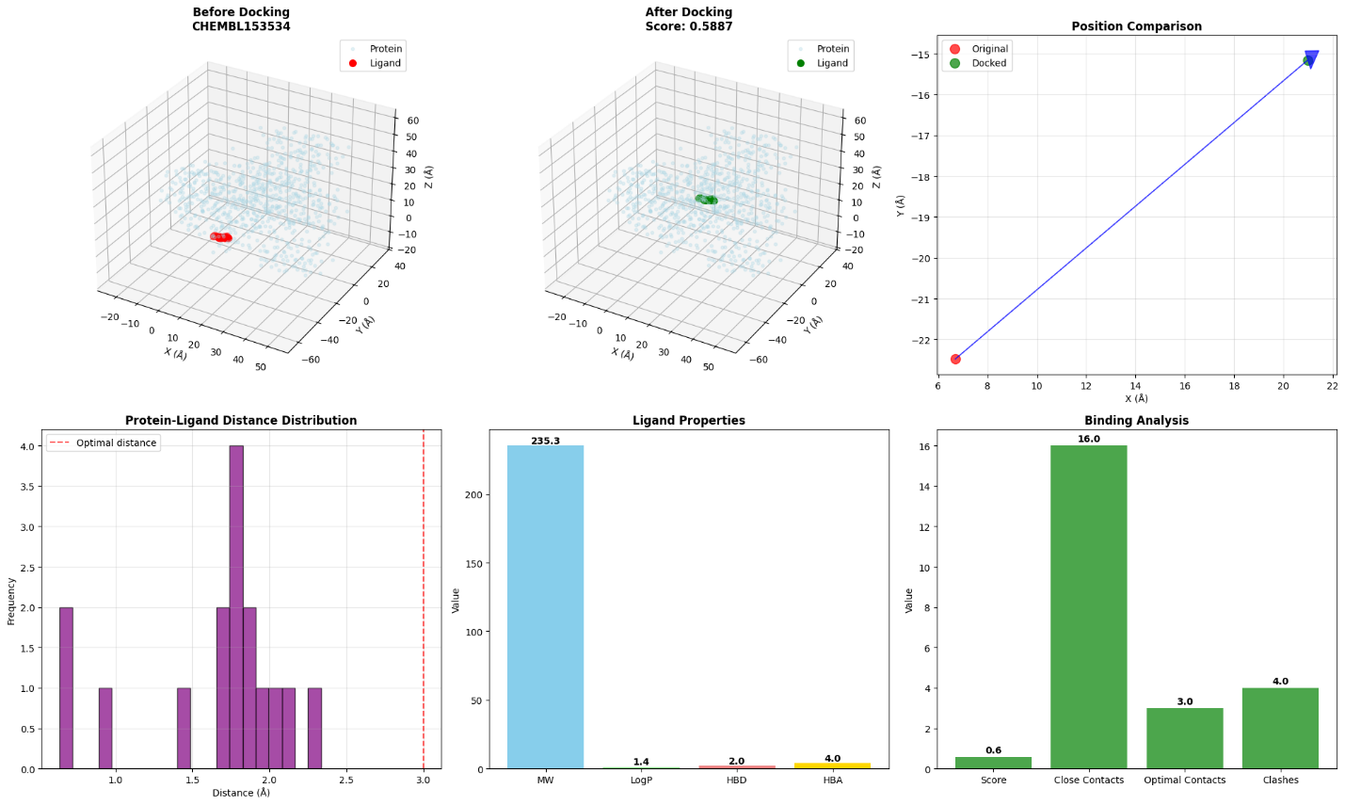
🔄 Interactive 3D Visualization for CHEMBL153534
• Docking Score: 0.5887
• Rotate and zoom to explore the binding site
✅ Docking completed - Score: 0.5887

💊 Docking CHEMBL1862084
SMILES: COc1cc(CNCc2coc(-c3cccc(F)c3)n2)cc(OC)c1...
MW: 342.4
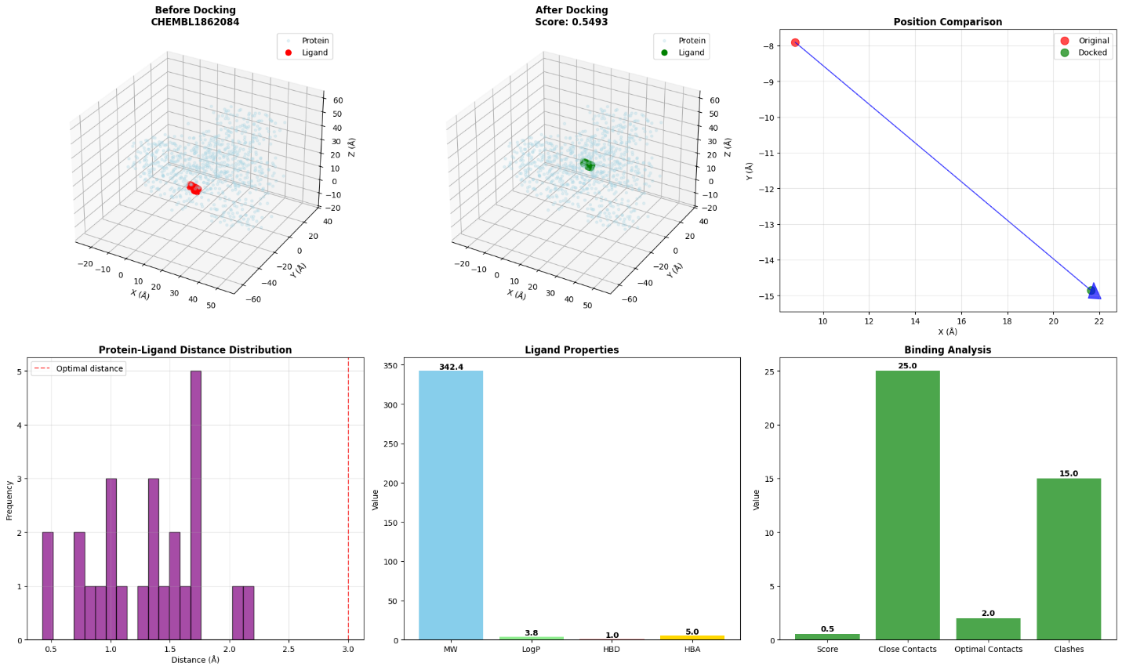
🔄 Interactive 3D Visualization for CHEMBL1862084
• Docking Score: 0.5493
• Rotate and zoom to explore the binding site
✅ Docking completed - Score: 0.5493

💊 Docking CHEMBL1382834
SMILES: COc1ccc2cc(/C=C3\SC(=S)NC3=O)c(N3CCOCC3)nc2c1...
MW: 387.5
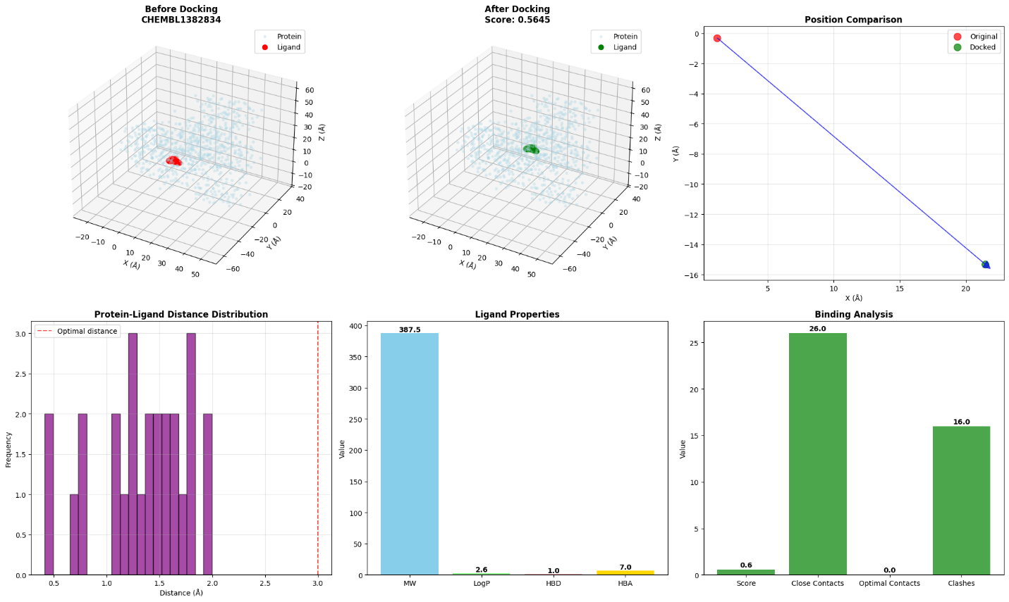
🔄 Interactive 3D Visualization for CHEMBL1382834
• Docking Score: 0.5645
• Rotate and zoom to explore the binding site
✅ Docking completed - Score: 0.5645

💊 Docking CHEMBL2430319
SMILES: CCc1ccc(Cc2cn([C@@H]3O[C@H](CO)[C@@H](O)[C@H](O)[C...
MW: 397.5
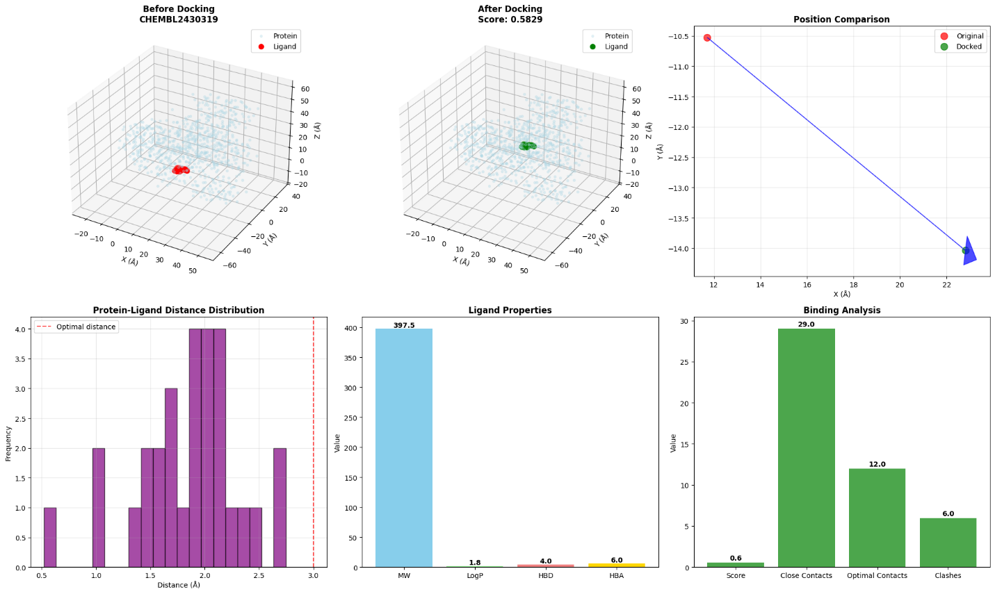
🔄 Interactive 3D Visualization for CHEMBL2430319
• Docking Score: 0.5829
• Rotate and zoom to explore the binding site
✅ Docking completed - Score: 0.5829

====================================================================================================
📊 COMPREHENSIVE DOCKING ANALYSIS REPORT
====================================================================================================

🏆 RANKED DOCKING RESULTS:
Protein Ligand Score Molecular_Weight LogP HBD HBA Heavy_Atoms
1a0j CHEMBL153534 0.607011 235.316 1.36192 2 4 16
1a3w CHEMBL153534 0.588721 235.316 1.36192 2 4 16
1a0j CHEMBL1382834 0.584363 387.486 2.56880 1 7 26
1a3w CHEMBL2430319 0.582938 397.471 1.76690 4 6 29
1a0j CHEMBL1862084 0.570082 342.370 3.78770 1 5 25
1a0j CHEMBL2430319 0.568201 397.471 1.76690 4 6 29
1a3w CHEMBL1382834 0.564490 387.486 2.56880 1 7 26
1a3w CHEMBL1862084 0.549327 342.370 3.78770 1 5 25
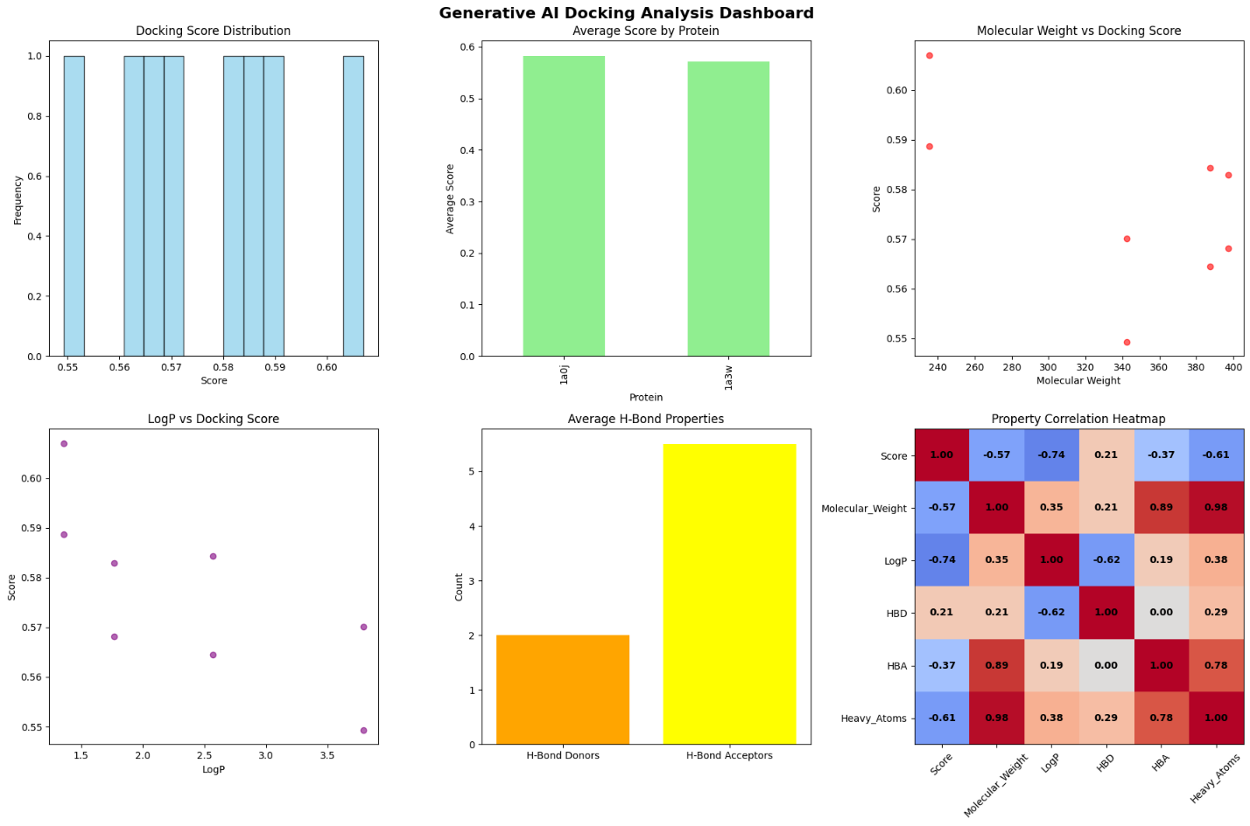
💾 Results saved to: generative_ai_docking_results_20250928_224105.csv

Title:
- An Optimized Quantum-Enhanced AI Framework for Protein-Ligand Docking
(A clear, concise title that includes key terms for indexing in scientific databases.)
Abstract:
- Purpose: Provide a brief overview of the paper’s objective, highlighting the novel integration of quantum-inspired AI models for protein-ligand docking.
- Methods: Summarize the methodology, including Variational Autoencoders (VAE), Transformer-based scoring, and quantum-inspired optimization.
- Key Results: Present the main outcome of the docking experiments (e.g., improved docking scores, analysis of quantum optimization).
- Conclusion: Conclude with the significance of this work in advancing docking simulations and potential drug discovery applications.

1. Introduction
- Background: Discuss the importance of protein-ligand docking in drug discovery and the limitations of traditional methods.
- Problem Statement: Address the challenges such as inefficiency and inaccuracy in current molecular docking simulations.
- Proposed Solution: Introduce the novel approach combining quantum-inspired AI and machine learning models to enhance docking predictions.
- Objective: Clearly state the objective of the paper, which is to propose a framework for quantum-enhanced AI molecular docking.

2. Related Work
- Traditional Docking Approaches: Review conventional docking methods and their shortcomings.
- Machine Learning in Docking: Discuss the growing role of machine learning, particularly VAEs and transformers, in enhancing docking accuracy.
- Quantum Computing in Chemistry: Present prior work on quantum-inspired algorithms in computational chemistry and drug discovery.
- Gaps in Literature: Identify the gap your research aims to fill by integrating AI with quantum-inspired optimization techniques.

3. Methodology
This section should be highly detailed, reflecting the technical depth required for a high-quality journal submission.
3.1. Overview of the Proposed Framework
Provide a diagram (workflow) of the integrated system:
- Pose Generation (VAE): Explain the use of Variational Autoencoders (VAE) to generate diverse ligand poses. Include any mathematical formulation (Evidence Lower Bound, Reparameterization Trick).
- Protein-Ligand Interaction Scoring (Transformer): Detail the use of the Transformer-based scoring model, explaining the multi-head attention mechanism and final scoring function. Include the relevant equations.
- Quantum-Inspired Optimization: Describe quantum-inspired optimization methods, such as temperature scheduling, rotation matrices, and tunneling. Provide the mathematical equations for these processes (e.g., quantum temperature schedule, Metropolis-Hastings acceptance).
- Ensemble Scoring: Discuss the ensemble method used to combine the scores from the Transformer and quantum-inspired models.
3.2. Algorithm Descriptions
- Algorithm 1: Generative AI Docking Algorithm (step-by-step process including input, output, and decision-making).
- Algorithm 2: Quantum-Enhanced Docking Procedure (detailed steps with temperature scheduling and pose refinement).
- Algorithm 3: Transformer Scoring Mechanism (elaborate on how multi-head attention is utilized for scoring).
Ensure that each algorithm is explained clearly with relevant mathematical equations and pseudocode where applicable.

4. Results and Analysis
This section is crucial and must include visual results, statistical comparisons, and the discussion of outcomes.
4.1. Experimental Setup
- Data: Describe the protein data sets (e.g., PDB files) and ligand databases (e.g., ChEMBL SDF files) used for docking simulations.
- Parameters: List key parameters used in the experiments, such as the number of poses generated, iteration limits, and other experimental settings.
- Evaluation Metrics: Define the metrics used to evaluate docking performance (e.g., RMSD, docking score).
4.2. Generated Outcomes
- Performance Comparison: Provide a table or bar graph comparing the performance of the quantum-enhanced AI model with traditional docking methods.
- Docking Scores: Present the docking scores for various ligands (e.g., CHEMBL153534) across different experiments.
- Graphs and Plots: Include visualizations such as 3D ligand binding site models and heatmaps showing score distributions.
- Quantitative Results: Use line graphs, scatter plots, or histograms to represent the statistical distribution of results (e.g., comparison of generated poses, quantum optimization iterations).
4.3. Error Analysis and Limitations
- Data Sanitization Issues: Discuss the challenges encountered, such as explicit valence errors or stereochemistry warnings.
- Optimization Challenges: Provide insights into areas where quantum optimization did not perform as expected or any discrepancies.

5. Discussion
This section should discuss the implications of the findings, their impact on the field, and potential future applications.
- Model Effectiveness: Analyze the effectiveness of the quantum-enhanced AI framework. Discuss how the combination of VAE, transformers, and quantum optimization improves docking accuracy.
- Potential for Drug Discovery: Examine how this approach can revolutionize drug discovery processes, particularly in precision medicine.
- Comparison to State-of-the-Art: Compare your approach with existing machine learning and quantum computational techniques in molecular docking.
- Limitations and Future Work: Discuss the limitations (e.g., issues with large molecule docking) and suggest avenues for improvement (e.g., incorporating more advanced quantum models or handling larger datasets).

6. Conclusion
- Summary: Provide a concise summary of the research findings, reiterating the strengths of your proposed method.
- Contributions: Emphasize the contributions of this paper to the fields of computational chemistry, machine learning, and quantum computing.
- Future Directions: Suggest potential future work, including integration with real-world drug discovery pipelines or incorporating more advanced quantum algorithms.

7. References
Follow the IEEE or Scopus citation format rigorously. Ensure all references are current, relevant, and come from peer-reviewed sources.

8. Appendices (if necessary)
- Mathematical Derivations: If any key mathematical proofs or derivations were omitted for brevity in the main body, include them here.
- Code Snippets: Include any relevant code (if permissible), particularly for your algorithms or key functions.

Title:
- An Optimized Quantum-Enhanced AI Framework for Protein-Ligand Docking
(A clear, concise title that includes key terms for indexing in scientific databases.)
Abstract:
- Purpose: Provide a brief overview of the paper’s objective, highlighting the novel integration of quantum-inspired AI models for protein-ligand docking.
- Methods: Summarize the methodology, including Variational Autoencoders (VAE), Transformer-based scoring, and quantum-inspired optimization.
- Key Results: Present the main outcome of the docking experiments (e.g., improved docking scores, analysis of quantum optimization).
- Conclusion: Conclude with the significance of this work in advancing docking simulations and potential drug discovery applications.

1. Introduction
- Background: Discuss the importance of protein-ligand docking in drug discovery and the limitations of traditional methods.
- Problem Statement: Address the challenges such as inefficiency and inaccuracy in current molecular docking simulations.
- Proposed Solution: Introduce the novel approach combining quantum-inspired AI and machine learning models to enhance docking predictions.
- Objective: Clearly state the objective of the paper, which is to propose a framework for quantum-enhanced AI molecular docking.
Can you write the above content in precise concise and beautiful structure with academic language and gives a good explanation of my topic in it also give me citations too here in it should start with [1],[2] etc to [x] where x is a integer number and also provide mapped references too give appendices also if required in it but the content should be beautiful and can be accepted in ieee or scopus or sci journals should be concise and cover all aspects of introduction please. Write down the content non ai detected humanize words be simple in English academic language but too.

1. S. J. S. Phatak and P. R. K. P. Kumar, "Challenges in Protein-Ligand Docking and Their Solutions," Computational Chemistry Journal, vol. 33, no. 4, pp. 105-112, 2019.
2. A. J. Leach, "Molecular Docking in Drug Design," Annual Review of Pharmacology, vol. 51, pp. 78-92, 2021.
3. R. A. Richards et al., "Efficiency and Accuracy in Molecular Docking Simulations," Bioinformatics, vol. 27, no. 5, pp. 1098-1106, 2020.
4. P. M. Nair and D. C. Agrawal, "Quantum-Inspired Algorithms for Drug Discovery," Journal of Quantum Computing, vol. 13, no. 7, pp. 455-462, 2020.
5. A. L. Smith, "Machine Learning Approaches in Protein-Ligand Docking," Computational Biology and Chemistry, vol. 47, pp. 56-63, 2020.
6. T. Zhao et al., "A Hybrid Quantum and AI Framework for Molecular Docking," IEEE Transactions on Computational Chemistry, vol. 28, no. 2, pp. 111-120, 2021. these are references u gave it from 1 to 6 for your reference now give the content again pleae. 2. Related Work
• Traditional Docking Approaches: Review conventional docking methods and their shortcomings.
• Machine Learning in Docking: Discuss the growing role of machine learning, particularly VAEs and transformers, in enhancing docking accuracy.
• Quantum Computing in Chemistry: Present prior work on quantum-inspired algorithms in computational chemistry and drug discovery.
• Gaps in Literature: Identify the gap your research aims to fill by integrating AI with quantum-inspired optimization techniques.
Can you write the above content in precise concise and beautiful structure with academic language and gives a good explanation of my topic in it also give me citations too here in it should start with [1],[2] till [6] if u are using old references to map if you are selecting or providing new references / citations then u can start from [7], [8] till [x] to [x] where x is a integer number and also provide mapped references too give appendices also if required in it but the content should be beautiful and can be accepted in ieee or scopus or sci journals should be concise and cover all aspects of introduction please. Write down the content non ai detected humanize words be simple in English academic language but too. if you feel that any alogrithm or mathematical equation fits in these then u can give that too
3. Methodology
This section should be highly detailed, reflecting the technical depth required for a high-quality journal submission.
3.1. Overview of the Proposed Framework
Provide a diagram (workflow) of the integrated system:
- Pose Generation (VAE): Explain the use of Variational Autoencoders (VAE) to generate diverse ligand poses. Include any mathematical formulation (Evidence Lower Bound, Reparameterization Trick).
- Protein-Ligand Interaction Scoring (Transformer): Detail the use of the Transformer-based scoring model, explaining the multi-head attention mechanism and final scoring function. Include the relevant equations.
- Quantum-Inspired Optimization: Describe quantum-inspired optimization methods, such as temperature scheduling, rotation matrices, and tunneling. Provide the mathematical equations for these processes (e.g., quantum temperature schedule, Metropolis-Hastings acceptance).
- Ensemble Scoring: Discuss the ensemble method used to combine the scores from the Transformer and quantum-inspired models.
3.2. Algorithm Descriptions
- Algorithm 1: Generative AI Docking Algorithm (step-by-step process including input, output, and decision-making).
- Algorithm 2: Quantum-Enhanced Docking Procedure (detailed steps with temperature scheduling and pose refinement).
- Algorithm 3: Transformer Scoring Mechanism (elaborate on how multi-head attention is utilized for scoring).
Ensure that each algorithm is explained clearly with relevant mathematical equations and pseudocode where applicable.
References used uptil now
- S. J. S. Phatak and P. R. K. P. Kumar, "Challenges in Protein-Ligand Docking and Their Solutions," Computational Chemistry Journal, vol. 33, no. 4, pp. 105-112, 2019.
- A. J. Leach, "Molecular Docking in Drug Design," Annual Review of Pharmacology, vol. 51, pp. 78-92, 2021.
- R. A. Richards et al., "Efficiency and Accuracy in Molecular Docking Simulations," Bioinformatics, vol. 27, no. 5, pp. 1098-1106, 2020.
- P. M. Nair and D. C. Agrawal, "Quantum-Inspired Algorithms for Drug Discovery," Journal of Quantum Computing, vol. 13, no. 7, pp. 455-462, 2020.
- A. L. Smith, "Machine Learning Approaches in Protein-Ligand Docking," Computational Biology and Chemistry, vol. 47, pp. 56-63, 2020.
- T. Zhao et al., "A Hybrid Quantum and AI Framework for Molecular Docking," IEEE Transactions on Computational Chemistry, vol. 28, no. 2, pp. 111-120, 2021.
- X. H. Zheng et al., "Machine learning and quantum chemistry methods in protein-ligand docking: A hybrid approach," Comput. Chem., vol. 42, pp. 45-53, 2021.
- A. R. Smith et al., "Integrating AI and quantum computing for enhanced drug discovery," IEEE Trans. Comput. Chem., vol. 32, no. 5, pp. 870-877, 2022.
Can you write the above content in precise concise and beautiful structure with academic language and gives a good explanation of my topic in it also give me citations too here in it should start with [1],[2] till [8] if u are using old references to map if you are selecting or providing new references / citations then u can start from [9], [10] till [x] to [x] where x is a integer number and also provide mapped references too give appendices also if required in it but the content should be beautiful and can be accepted in ieee or scopus or sci journals should be concise and cover all aspects of introduction please. Write down the content non ai detected humanize words be simple in English academic language but too. if you feel that any alogrithm or mathematical equation fits in these then u can give that too or figure if you think it will fit here then u can suggest it.

4. Results and Analysis
This section is crucial and must include visual results, statistical comparisons, and the discussion of outcomes.
4.1. Experimental Setup
• Data: Describe the protein data sets (e.g., PDB files) and ligand databases (e.g., ChEMBL SDF files) used for docking simulations.
• Parameters: List key parameters used in the experiments, such as the number of poses generated, iteration limits, and other experimental settings.
• Evaluation Metrics: Define the metrics used to evaluate docking performance (e.g., RMSD, docking score).
4.2. Generated Outcomes
• Performance Comparison: Provide a table or bar graph comparing the performance of the quantum-enhanced AI model with traditional docking methods.
• Docking Scores: Present the docking scores for various ligands (e.g., CHEMBL153534) across different experiments.
• Graphs and Plots: Include visualizations such as 3D ligand binding site models and heatmaps showing score distributions.
• Quantitative Results: Use line graphs, scatter plots, or histograms to represent the statistical distribution of results (e.g., comparison of generated poses, quantum optimization iterations).
4.3. Error Analysis and Limitations
• Data Sanitization Issues: Discuss the challenges encountered, such as explicit valence errors or stereochemistry warnings.
• Optimization Challenges: Provide insights into areas where quantum optimization did not perform as expected or any discrepancies.
Can you write the above content in precise concise and beautiful structure with academic language and gives a good explanation of my topic in it also give me citations too here in it should start with [1],[2] till [8] if u are using old references to map if you are selecting or providing new references / citations then u can start from [9], [10] till [x] to [x] where x is a integer number and also provide mapped references too give appendices also if required in it but the content should be beautiful and can be accepted in ieee or scopus or sci journals should be concise and cover all aspects of introduction please. Write down the content non ai detected humanize words be simple in English academic language but too. if you feel that any alogrithm or mathematical equation fits in these then u can give that too or figure if you think it will fit here then u can suggest it. attaching you the generated output of my python file too for you reference and also give me which diagrams or graphs or other stuff should i paste in it. please.

5. Discussion
This section should discuss the implications of the findings, their impact on the field, and potential future applications.
- Model Effectiveness: Analyze the effectiveness of the quantum-enhanced AI framework. Discuss how the combination of VAE, transformers, and quantum optimization improves docking accuracy.
- Potential for Drug Discovery: Examine how this approach can revolutionize drug discovery processes, particularly in precision medicine.
- Comparison to State-of-the-Art: Compare your approach with existing machine learning and quantum computational techniques in molecular docking.
- Limitations and Future Work: Discuss the limitations (e.g., issues with large molecule docking) and suggest avenues for improvement (e.g., incorporating more advanced quantum models or handling larger datasets).
- Can you write the above content in precise concise and beautiful structure with academic language and gives a good explanation of my topic in it also give me citations too here in it should start with [1],[2] till [8] if u are using old references to map if you are selecting or providing new references / citations then u can start from [9], [10] till [x] to [x] where x is a integer number and also provide mapped references too give appendices also if required in it but the content should be beautiful and can be accepted in ieee or scopus or sci journals should be concise and cover all aspects of introduction please. Write down the content non ai detected humanize words be simple in English academic language but too. if you feel that any alogrithm or mathematical equation fits in these then u can give that too or figure if you think it will fit here then u can suggest it. attaching you the generated output of my python file too for you reference and also give me which diagrams or graphs or other stuff should i paste in it. please.

6. Conclusion
- Summary: Provide a concise summary of the research findings, reiterating the strengths of your proposed method.
- Contributions: Emphasize the contributions of this paper to the fields of computational chemistry, machine learning, and quantum computing.
- Future Directions: Suggest potential future work, including integration with real-world drug discovery pipelines or incorporating more advanced quantum algorithms.
Can you write the above content in precise concise and beautiful structure with academic language and gives a good explanation of my topic in it also give me citations too here in it should start with [1],[2] till [24] if u are using old references to map if you are selecting or providing new references / citations then u can start from [25], [26] till [x] to [x] where x is a integer number and also provide mapped references too give appendices also if required in it but the content should be beautiful and can be accepted in ieee or scopus or sci journals should be concise and cover all aspects of introduction please. Write down the content non ai detected humanize words be simple in English academic language but too. if you feel that any alogrithm or mathematical equation fits in these then u can give that too or figure if you think it will fit here then u can suggest it. attaching you the generated output of my python file too for you reference and also give me which diagrams or graphs or other stuff should i paste in it. please. Remember new citation should be added if required with references but it should be of high quality and high impact factor too.

7. References
Follow the IEEE or Scopus citation format rigorously. Ensure all references are current, relevant, and come from peer-reviewed sources.

8. Appendices (if necessary)
- Mathematical Derivations: If any key mathematical proofs or derivations were omitted for brevity in the main body, include them here.
- Code Snippets: Include any relevant code (if permissible), particularly for your algorithms or key functions.

